ASA Research

Microsoft Excel Functions, Marcos &
Data Commands
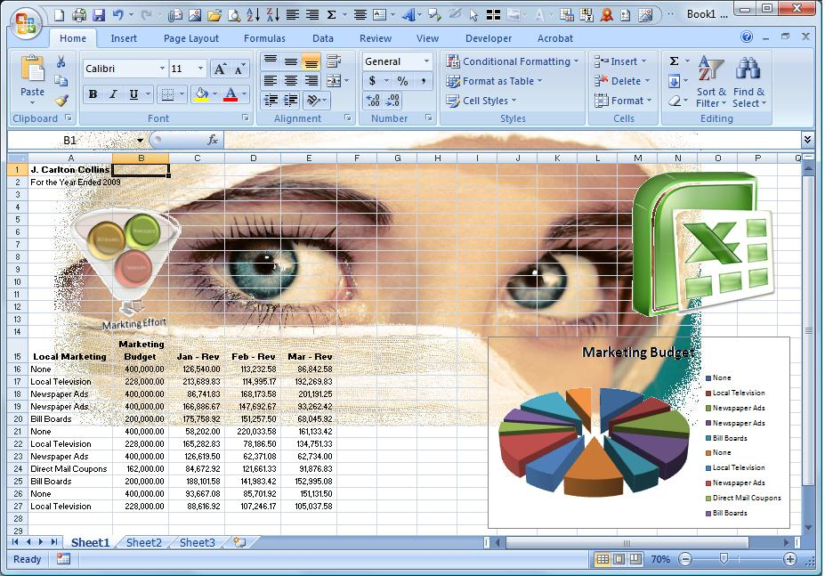

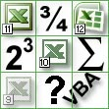
J. Carlton Collins
ASA Research - Atlanta, Georgia
770.734.0950
Carlton@ASAResearch.com

Table of Contents

Course Information 3

Chapter 1 – All Functions 4

Chapter 2 – The If Function 17

Chapter 3 – Using Functions to Crunch & Clean Data 22

Chapter 4 – Data Commands 40

Chapter 5 - Macros 72

Chapter 6 – Miscellaneous 75

Chapter 7 – XML Data 83

Chapter 8 – Quick Tips 91

Chapter 9 – New in Excel 2007 94

Appendix - Instructor’s Biography 105

Excel Functions, Marcos & Data Commands
Course Information

Learning Objectives | To increase the productivity of accountants and CPAs using Excel’s functions, macros, & data commands
Course Level | Intermediate
Pre-Requisites | Good Familiarity with Microsoft Excel
Advanced Preparation | None
Presentation Method | Live lecture using full color projection systems and live Internet access with follow up course materials
Recommended CPE Credit | 8 hours
Handouts | Templates, checklists, web examples, manual
Instructors | J. Carlton Collins, CPA
 | AdvisorCPE is registered with the National Association of State Boards of Accountancy (NASBA) as a sponsor of continuing professional education on the National Registry of CPE Sponsors. State boards of accountancy have final authority on the acceptance of individual courses for CPE credit. Complaints regarding registered sponsors may be addressed to the national Registry of CPE Sponsors, 150 Fourth Avenue, Nashville, TN, 37219-2417. Telephone: 615-880-4200.

Copyright © August 2009, AdvisorCPE and Accounting Software Advisor, LLC
4480 Missendell Lane, Norcross, Georgia 30092 770.734.0450

All rights reserved. No part of this publication may be reproduced or transmitted in any form without the express written consent of AdvisorCPE, a subsidiary of ASA Research. Request may be e-mailed to marylou@advisorcpe.com or further information can be obtained by calling 770.734.0450 or by accessing the AdvisorCPE home page at: http://www.advisorcpe.com/

All trade names and trademarks used in these materials are the property of their respective manufacturers and/or owners. The use of trade names and trademarks used in these materials are not intended to convey endorsement of any other affiliations with these materials. Any abbreviations used herein are solely for the reader’s convenience and are not intended to compromise any trademarks. Some of the features discussed within this manual apply only to certain versions of Excel, and from time to time, Microsoft might remove some functionality. Microsoft Excel is known to contain numerous software bugs which may prevent the successful use of some features in some cases. AdvisorCPE makes no representations or warranty with respect to the contents of these materials and disclaims any implied warranties of merchantability of fitness for any particular use. The contents of these materials are subject to change without notice.

Contact Information:

J. Carlton Collins

carlton@asaresearch.com

770.734.0950



Chapter 1

All Functions

Introduction to Excel Functions

Excel Functions are preprogrammed commands that make the task of writing complex formulas easier. There are a total of 333 functions in Excel. These functions are separated into 11 categories as follows:

- Database Functions (12)
- Date and Time Functions (20)
- Engineering Functions (39)
- Financial Functions (53)
- Information Functions (17)
- Logical Functions (6)
- Lookup and Reference Functions (18)
- Math and Trigonometry Functions (59)
- Statistical Functions (80)
- Text Functions (27)
- External Functions (2)
Some Excel functions are more powerful than others and some are more relevant to the CPA than others. For example, most CPAs will find the IF, SUM, COUNT, SUBTOTAL, TEXT, and VLOOKUP are very relevant to the CPA while other engineering and trigonometry functions such as LOG, PI, RADIENS, DELTA, TAN, COMPLEX, and HAX2DEC are typically less relevant to CPAs. It has been my experience that the following 67 functions are most relevant to the CPA; therefore CPAs wishing to increase their command of Excel functions should concentrate on these functions first.

Carlton’s List of The Top 67 Functions Most Relevant to CPAs
Sorted By Carlton’s Opinion of the Most Useful

- IF | - SUM | - SUMIF | - COUNT | - COUNTA
- AVERAGE | - COUNTBLANK | - COUNTIF | - VALUE | - TEXT
- VLOOKUP | - HLOOKUP | - LOOKUP | - TRIM | - PROPER
- LOWER | - LEFT, LEFTB | - MID, MIDB | - RIGHT, RIGHTB | - FIND, FINDB
- REPLACE | - CONCATENATE | - CLEAN | - UPPER | - LEN, LENB
- SUBSTITUTE | - NOW | - TODAY | - MONTH | - DATE
- DAY | - YEAR | - WEEKDAY | - ROUND | - ROUNDDOWN
- ROUNDUP | - MAX | - MIN | - MEDIAN | - MODE
- PERCENTILE | - PERCENTRANK | - PMT | - NPV | - DSUM
- DCOUNT | - DCOUNTA | - AND | - OR | - CHOOSE
- TIME | - FV | - IRR | - YIELD | - CELL
- ERROR.TYPE | - INFO | - ISBLANK | - ISNA | - GETPIVOTDATA
- HYPERLINK | - TRANSPOSE | - ABS | - RAND | - RANDBETWEEN
- CONFIDENCE | - REPT
Following is a list of all Excel functions, organized by category, including a description of each function.

 | Database Functions
 | Function | Description
1 | DAVERAGE | Returns the average of selected database entries
2 | DCOUNT | Counts the cells that contain numbers in a database
3 | DCOUNTA | Counts nonblank cells in a database
4 | DGET | Extracts from a database a single record that matches the specified criteria
5 | DMAX | Returns the maximum value from selected database entries
6 | DMIN | Returns the minimum value from selected database entries
7 | DPRODUCT | Multiplies the values in a particular field of records that match the criteria in a database
8 | DSTDEV | Estimates the standard deviation based on a sample of selected database entries
9 | DSTDEVP | Calculates the standard deviation based on the entire population of selected database entries
10 | DSUM | Adds the numbers in the field column of records in the database that match the criteria
11 | DVAR | Estimates variance based on a sample from selected database entries
12 | DVARP | Calculates variance based on the entire population of selected database entries
 | Date and Time Functions
 | Function | Description
13 | DATE | Returns the serial number of a particular date
14 | DATEVALUE | Converts a date in the form of text to a serial number
15 | DAY | Converts a serial number to a day of the month
16 | DAYS360 | Calculates the number of days between two dates based on a 360-day year
17 | EDATE | Returns the serial number of the date that is the indicated number of months before or after the start date
18 | EOMONTH | Returns the serial number of the last day of the month before or after a specified number of months
19 | HOUR | Converts a serial number to an hour
20 | MINUTE | Converts a serial number to a minute
21 | MONTH | Converts a serial number to a month
22 | NETWORKDAYS | Returns the number of whole workdays between two dates
23 | NOW | Returns the serial number of the current date and time
24 | SECOND | Converts a serial number to a second
25 | TIME | Returns the serial number of a particular time
26 | TIMEVALUE | Converts a time in the form of text to a serial number
27 | TODAY | Returns the serial number of today's date
28 | WEEKDAY | Converts a serial number to a day of the week
29 | WEEKNUM | Converts a serial number to a number representing where the week falls numerically with a year
30 | WORKDAY | Returns the serial number of the date before or after a specified number of workdays
31 | YEAR | Converts a serial number to a year
32 | YEARFRAC | Returns the year fraction representing the number of whole days between start_date and end_date
 | Engineering Functions
 | Function | Description
33 | BESSELI | Returns the modified Bessel Function In(x)
34 | BESSELJ | Returns the Bessel Function Jn(x)
35 | BESSELK | Returns the modified Bessel Function Kn(x)
36 | BESSELY | Returns the Bessel Function Yn(x)
37 | BIN2DEC | Converts a binary number to decimal
38 | BIN2HEX | Converts a binary number to hexadecimal
39 | BIN2OCT | Converts a binary number to octal
40 | COMPLEX | Converts real and imaginary coefficients into a complex number
41 | CONVERT | Converts a number from one measurement system to another
42 | DEC2BIN | Converts a decimal number to binary
43 | DEC2HEX | Converts a decimal number to hexadecimal
44 | DEC2OCT | Converts a decimal number to octal
45 | DELTA | Tests whether two values are equal
46 | ERF | Returns the error Function
47 | ERFC | Returns the complementary error Function
48 | GESTEP | Tests whether a number is greater than a threshold value
49 | HEX2BIN | Converts a hexadecimal number to binary
50 | HEX2DEC | Converts a hexadecimal number to decimal
51 | HEX2OCT | Converts a hexadecimal number to octal
52 | IMABS | Returns the absolute value (modulus) of a complex number
53 | IMAGINARY | Returns the imaginary coefficient of a complex number
54 | IMARGUMENT | Returns the argument theta, an angle expressed in radians
55 | IMCONJUGATE | Returns the complex conjugate of a complex number
56 | IMCOS | Returns the cosine of a complex number
57 | IMDIV | Returns the quotient of two complex numbers
58 | IMEXP | Returns the exponential of a complex number
59 | IMLN | Returns the natural logarithm of a complex number
60 | IMLOG10 | Returns the base-10 logarithm of a complex number
61 | IMLOG2 | Returns the base-2 logarithm of a complex number
62 | IMPOWER | Returns a complex number raised to an integer power
63 | IMPRODUCT | Returns the product of from 2 to 29 complex numbers
64 | IMREAL | Returns the real coefficient of a complex number
65 | IMSIN | Returns the sine of a complex number
66 | IMSQRT | Returns the square root of a complex number
67 | IMSUB | Returns the difference between two complex numbers
68 | IMSUM | Returns the sum of complex numbers
69 | OCT2BIN | Converts an octal number to binary
70 | OCT2DEC | Converts an octal number to decimal
71 | OCT2HEX | Converts an octal number to hexadecimal
 | Financial Functions
 | Function | Description
72 | ACCRINT | Returns the accrued interest for a security that pays periodic interest
73 | ACCRINTM | Returns the accrued interest for a security that pays interest at maturity
74 | AMORDEGRC | Returns the depreciation for each accounting period by using a depreciation coefficient
75 | AMORLINC | Returns the depreciation for each accounting period
76 | COUPDAYBS | Returns the number of days from the beginning of the coupon period to the settlement date
77 | COUPDAYS | Returns the number of days in the coupon period that contains the settlement date
78 | COUPDAYSNC | Returns the number of days from the settlement date to the next coupon date
79 | COUPNCD | Returns the next coupon date after the settlement date
80 | COUPNUM | Returns the number of coupons payable between the settlement date and maturity date
81 | COUPPCD | Returns the previous coupon date before the settlement date
82 | CUMIPMT | Returns the cumulative interest paid between two periods
83 | CUMPRINC | Returns the cumulative principal paid on a loan between two periods
84 | DB | Returns the depreciation of an asset for a specified period by using the fixed-declining balance method
85 | DDB | Returns the depreciation of an asset for a specified period by using the double-declining balance method or some other method that you specify
86 | DISC | Returns the discount rate for a security
87 | DOLLARDE | Converts a dollar price, expressed as a fraction, into a dollar price, expressed as a decimal number
88 | DOLLARFR | Converts a dollar price, expressed as a decimal number, into a dollar price, expressed as a fraction
89 | DURATION | Returns the annual duration of a security with periodic interest payments
90 | EFFECT | Returns the effective annual interest rate
91 | FV | Returns the future value of an investment
92 | FVSCHEDULE | Returns the future value of an initial principal after applying a series of compound interest rates
93 | INTRATE | Returns the interest rate for a fully invested security
94 | IPMT | Returns the interest payment for an investment for a given period
95 | IRR | Returns the internal rate of return for a series of cash flows
96 | ISPMT | Calculates the interest paid during a specific period of an investment
97 | MDURATION | Returns the Macauley modified duration for a security with an assumed par value of $100
98 | MIRR | Returns the internal rate of return where positive and negative cash flows are financed at different rates
99 | NOMINAL | Returns the annual nominal interest rate
100 | NPER | Returns the number of periods for an investment
101 | NPV | Returns the net present value of an investment based on a series of periodic cash flows and a discount rate
102 | ODDFPRICE | Returns the price per $100 face value of a security with an odd first period
103 | ODDFYIELD | Returns the yield of a security with an odd first period
104 | ODDLPRICE | Returns the price per $100 face value of a security with an odd last period
105 | ODDLYIELD | Returns the yield of a security with an odd last period
106 | PMT | Returns the periodic payment for an annuity
107 | PPMT | Returns the payment on the principal for an investment for a given period
108 | PRICE | Returns the price per $100 face value of a security that pays periodic interest
109 | PRICEDISC | Returns the price per $100 face value of a discounted security
110 | PRICEMAT | Returns the price per $100 face value of a security that pays interest at maturity
111 | PV | Returns the present value of an investment
112 | RATE | Returns the interest rate per period of an annuity
113 | RECEIVED | Returns the amount received at maturity for a fully invested security
114 | SLN | Returns the straight-line depreciation of an asset for one period
115 | SYD | Returns the sum-of-years' digits depreciation of an asset for a specified period
116 | TBILLEQ | Returns the bond-equivalent yield for a Treasury bill
117 | TBILLPRICE | Returns the price per $100 face value for a Treasury bill
118 | TBILLYIELD | Returns the yield for a Treasury bill
119 | VDB | Returns the depreciation of an asset for a specified or partial period by using a declining balance method
120 | XIRR | Returns the internal rate of return for a schedule of cash flows that is not necessarily periodic
121 | XNPV | Returns the net present value for a schedule of cash flows that is not necessarily periodic
122 | YIELD | Returns the yield on a security that pays periodic interest
123 | YIELDDISC | Returns the annual yield for a discounted security; for example, a Treasury bill
124 | YIELDMAT | Returns the annual yield of a security that pays interest at maturity
 | Information Functions
 | Function | Description
125 | CELL | Returns information about the formatting, location, or contents of a cell
126 | ERROR.TYPE | Returns a number corresponding to an error type
127 | INFO | Returns information about the current operating environment
128 | ISBLANK | Returns TRUE if the value is blank
129 | ISERR | Returns TRUE if the value is any error value except #N/A
130 | ISERROR | Returns TRUE if the value is any error value
131 | ISEVEN | Returns TRUE if the number is even
132 | ISLOGICAL | Returns TRUE if the value is a logical value
133 | ISNA | Returns TRUE if the value is the #N/A error value
134 | ISNONTEXT | Returns TRUE if the value is not text
135 | ISNUMBER | Returns TRUE if the value is a number
136 | ISODD | Returns TRUE if the number is odd
137 | ISREF | Returns TRUE if the value is a reference
138 | ISTEXT | Returns TRUE if the value is text
139 | N | Returns a value converted to a number
140 | NA | Returns the error value #N/A
141 | TYPE | Returns a number indicating the data type of a value
17
 | Logical Functions
 | Function | Description
142 | AND | Returns TRUE if all of its arguments are TRUE
143 | FALSE | Returns the logical value FALSE
144 | IF | Specifies a logical test to perform
145 | NOT | Reverses the logic of its argument
146 | OR | Returns TRUE if any argument is TRUE
147 | TRUE | Returns the logical value TRUE
 | Lookup and Reference Functions
 | Function | Description
148 | ADDRESS | Returns a reference as text to a single cell in a worksheet
149 | AREAS | Returns the number of areas in a reference
150 | CHOOSE | Chooses a value from a list of values
151 | COLUMN | Returns the column number of a reference
152 | COLUMNS | Returns the number of columns in a reference
153 | GETPIVOTDATA | Returns data stored in a PivotTable
154 | HLOOKUP | Looks in the top row of an array and returns the value of the indicated cell
155 | HYPERLINK | Creates a shortcut or jump that opens a document stored on a network server, an intranet, or the Internet
156 | INDEX | Uses an index to choose a value from a reference or array
157 | INDIRECT | Returns a reference indicated by a text value
158 | LOOKUP | Looks up values in a vector or array
159 | MATCH | Looks up values in a reference or array
160 | OFFSET | Returns a reference offset from a given reference
161 | ROW | Returns the row number of a reference
162 | ROWS | Returns the number of rows in a reference
163 | RTD | Retrieves real-time data from a program that supports COM automation (Automation: A way to work with an application's objects from another application or development tool. Formerly called OLE Automation, Automation is an industry standard and a feature of the Component Object Model (COM).)
164 | TRANSPOSE | Returns the transpose of an array
165 | VLOOKUP | Looks in the first column of an array and moves across the row to return the value of a cell
 | Math and Trigonometry Functions
 | Function | Description
166 | ABS | Returns the absolute value of a number
167 | ACOS | Returns the arccosine of a number
168 | ACOSH | Returns the inverse hyperbolic cosine of a number
169 | ASIN | Returns the arcsine of a number
170 | ASINH | Returns the inverse hyperbolic sine of a number
171 | ATAN | Returns the arctangent of a number
172 | ATAN2 | Returns the arctangent from x- and y-coordinates
173 | ATANH | Returns the inverse hyperbolic tangent of a number
174 | CEILING | Rounds a number to the nearest integer or to the nearest multiple of significance
175 | COMBIN | Returns the number of combinations for a given number of objects
176 | COS | Returns the cosine of a number
177 | COSH | Returns the hyperbolic cosine of a number
178 | DEGREES | Converts radians to degrees
179 | EVEN | Rounds a number up to the nearest even integer
180 | EXP | Returns e raised to the power of a given number
181 | FACT | Returns the factorial of a number
182 | FACTDOUBLE | Returns the double factorial of a number
183 | FLOOR | Rounds a number down, toward zero
184 | GCD | Returns the greatest common divisor
185 | INT | Rounds a number down to the nearest integer
186 | LCM | Returns the least common multiple
187 | LN | Returns the natural logarithm of a number
188 | LOG | Returns the logarithm of a number to a specified base
189 | LOG10 | Returns the base-10 logarithm of a number
190 | MDETERM | Returns the matrix determinant of an array
191 | MINVERSE | Returns the matrix inverse of an array
192 | MMULT | Returns the matrix product of two arrays
193 | MOD | Returns the remainder from division
194 | MROUND | Returns a number rounded to the desired multiple
195 | MULTINOMIAL | Returns the multinomial of a set of numbers
196 | ODD | Rounds a number up to the nearest odd integer
197 | PI | Returns the value of pi
198 | POWER | Returns the result of a number raised to a power
199 | PRODUCT | Multiplies its arguments
200 | QUOTIENT | Returns the integer portion of a division
201 | RADIANS | Converts degrees to radians
202 | RAND | Returns a random number between 0 and 1
203 | RANDBETWEEN | Returns a random number between the numbers you specify
204 | ROMAN | Converts an arabic numeral to roman, as text
205 | ROUND | Rounds a number to a specified number of digits
206 | ROUNDDOWN | Rounds a number down, toward zero
207 | ROUNDUP | Rounds a number up, away from zero
208 | SERIESSUM | Returns the sum of a power series based on the formula
209 | SIGN | Returns the sign of a number
210 | SIN | Returns the sine of the given angle
211 | SINH | Returns the hyperbolic sine of a number
212 | SQRT | Returns a positive square root
213 | SQRTPI | Returns the square root of (number * pi)
214 | SUBTOTAL | Returns a subtotal in a list or database
215 | SUM | Adds its arguments
216 | SUMIF | Adds the cells specified by a given criteria
217 | SUMPRODUCT | Returns the sum of the products of corresponding array components
218 | SUMSQ | Returns the sum of the squares of the arguments
219 | SUMX2MY2 | Returns the sum of the difference of squares of corresponding values in two arrays
220 | SUMX2PY2 | Returns the sum of the sum of squares of corresponding values in two arrays
221 | SUMXMY2 | Returns the sum of squares of differences of corresponding values in two arrays
222 | TAN | Returns the tangent of a number
223 | TANH | Returns the hyperbolic tangent of a number
224 | TRUNC | Truncates a number to an integer
 | Statistical Functions
 | Function | Description
225 | AVEDEV | Returns the average of the absolute deviations of data points from their mean
226 | AVERAGE | Returns the average of its arguments
227 | AVERAGEA | Returns the average of its arguments, including numbers, text, and logical values
228 | BETADIST | Returns the beta cumulative distribution Function
229 | BETAINV | Returns the inverse of the cumulative distribution Function for a specified beta distribution
230 | BINOMDIST | Returns the individual term binomial distribution probability
231 | CHIDIST | Returns the one-tailed probability of the chi-squared distribution
232 | CHIINV | Returns the inverse of the one-tailed probability of the chi-squared distribution
233 | CHITEST | Returns the test for independence
234 | CONFIDENCE | Returns the confidence interval for a population mean
235 | CORREL | Returns the correlation coefficient between two data sets
236 | COUNT | Counts how many numbers are in the list of arguments
237 | COUNTA | Counts how many values are in the list of arguments
238 | COUNTBLANK | Counts the number of blank cells within a range
239 | COUNTIF | Counts the number of nonblank cells within a range that meet the given criteria
240 | COVAR | Returns covariance, the average of the products of paired deviations
241 | CRITBINOM | Returns the smallest value for which the cumulative binomial distribution is less than or equal to a criterion value
242 | DEVSQ | Returns the sum of squares of deviations
243 | EXPONDIST | Returns the exponential distribution
244 | FDIST | Returns the F probability distribution
245 | FINV | Returns the inverse of the F probability distribution
246 | FISHER | Returns the Fisher transformation
247 | FISHERINV | Returns the inverse of the Fisher transformation
248 | FORECAST | Returns a value along a linear trend
249 | FREQUENCY | Returns a frequency distribution as a vertical array
250 | FTEST | Returns the result of an F-test
251 | GAMMADIST | Returns the gamma distribution
252 | GAMMAINV | Returns the inverse of the gamma cumulative distribution
253 | GAMMALN | Returns the natural logarithm of the gamma Function, Γ(x)
254 | GEOMEAN | Returns the geometric mean
255 | GROWTH | Returns values along an exponential trend
256 | HARMEAN | Returns the harmonic mean
257 | HYPGEOMDIST | Returns the hypergeometric distribution
258 | INTERCEPT | Returns the intercept of the linear regression line
259 | KURT | Returns the kurtosis of a data set
260 | LARGE | Returns the k-th largest value in a data set
261 | LINEST | Returns the parameters of a linear trend
262 | LOGEST | Returns the parameters of an exponential trend
263 | LOGINV | Returns the inverse of the lognormal distribution
264 | LOGNORMDIST | Returns the cumulative lognormal distribution
265 | MAX | Returns the maximum value in a list of arguments
266 | MAXA | Returns the maximum value in a list of arguments, including numbers, text, and logical values
267 | MEDIAN | Returns the median of the given numbers
268 | MIN | Returns the minimum value in a list of arguments
269 | MINA | Returns the smallest value in a list of arguments, including numbers, text, and logical values
270 | MODE | Returns the most common value in a data set
271 | NEGBINOMDIST | Returns the negative binomial distribution
272 | NORMDIST | Returns the normal cumulative distribution
273 | NORMINV | Returns the inverse of the normal cumulative distribution
274 | NORMSDIST | Returns the standard normal cumulative distribution
275 | NORMSINV | Returns the inverse of the standard normal cumulative distribution
276 | PEARSON | Returns the Pearson product moment correlation coefficient
277 | PERCENTILE | Returns the k-th percentile of values in a range
278 | PERCENTRANK | Returns the percentage rank of a value in a data set
279 | PERMUT | Returns the number of permutations for a given number of objects
280 | POISSON | Returns the Poisson distribution
281 | PROB | Returns the probability that values in a range are between two limits
282 | QUARTILE | Returns the quartile of a data set
283 | RANK | Returns the rank of a number in a list of numbers
284 | RSQ | Returns the square of the Pearson product moment correlation coefficient
285 | SKEW | Returns the skewness of a distribution
286 | SLOPE | Returns the slope of the linear regression line
287 | SMALL | Returns the k-th smallest value in a data set
288 | STANDARDIZE | Returns a normalized value
289 | STDEV | Estimates standard deviation based on a sample
290 | STDEVA | Estimates standard deviation based on a sample, including numbers, text, and logical values
291 | STDEVP | Calculates standard deviation based on the entire population
292 | STDEVPA | Calculates standard deviation based on the entire population, including numbers, text, and logical values
293 | STEYX | Returns the standard error of the predicted y-value for each x in the regression
294 | TDIST | Returns the Student's t-distribution
295 | TINV | Returns the inverse of the Student's t-distribution
296 | TREND | Returns values along a linear trend
297 | TRIMMEAN | Returns the mean of the interior of a data set
298 | TTEST | Returns the probability associated with a Student's t-test
299 | VAR | Estimates variance based on a sample
300 | VARA | Estimates variance based on a sample, including numbers, text, and logical values
301 | VARP | Calculates variance based on the entire population
302 | VARPA | Calculates variance based on the entire population, including numbers, text, and logical values
303 | WEIBULL | Returns the Weibull distribution
304 | ZTEST | Returns the one-tailed probability-value of a z-test
 | Text Functions
 | Function | Description
305 | ASC | Changes full-width (double-byte) English letters or katakana within a character string to half-width (single-byte) characters
306 | BAHTTEXT | Converts a number to text, using the ß (baht) currency format
307 | CHAR | Returns the character specified by the code number
308 | CLEAN | Removes all nonprintable characters from text
309 | CODE | Returns a numeric code for the first character in a text string
310 | CONCATENATE | Joins several text items into one text item
311 | DOLLAR | Converts a number to text, using the $ (dollar) currency format
312 | EXACT | Checks to see if two text values are identical
313 | FIND, FINDB | Finds one text value within another (case-sensitive)
314 | FIXED | Formats a number as text with a fixed number of decimals
315 | JIS | Changes half-width (single-byte) English letters or katakana within a character string to full-width (double-byte) characters
316 | LEFT, LEFTB | Returns the leftmost characters from a text value
317 | LEN, LENB | Returns the number of characters in a text string
318 | LOWER | Converts text to lowercase
319 | MID, MIDB | Returns a specific number of characters from a text string starting at the position you specify
320 | PHONETIC | Extracts the phonetic (furigana) characters from a text string
321 | PROPER | Capitalizes the first letter in each word of a text value
322 | REPLACE, REPLACEB | Replaces characters within text
323 | REPT | Repeats text a given number of times
324 | RIGHT, RIGHTB | Returns the rightmost characters from a text value
325 | SEARCH, SEARCHB | Finds one text value within another (not case-sensitive)
326 | SUBSTITUTE | Substitutes new text for old text in a text string
327 | T | Converts its arguments to text
328 | TEXT | Formats a number and converts it to text
329 | TRIM | Removes spaces from text
330 | UPPER | Converts text to uppercase
331 | VALUE | Converts a text argument to a number
 | External Functions
 | Function | Description
332 | EUROCONVERT | Converts a number to euros, converts a number from euros to a euro member currency, or converts a number from one euro member currency to another by using the euro as an intermediary (triangulation)
333 | SQL.REQUEST | Connects with an external data source and runs a query from a worksheet, then returns the result as an array without the need for macro programming

Chapter 2

The =IF Function

=IF

The “IF” function is the most powerful of all functions – not just in Excel, but in any programming language. Commonly referred to as “Conditional Programming”, it is the IF function that enables us to introduce logical thinking into any program. This function is also referred to as the “If-Then-Else” command, “conditional expressions”, or “Propositional Logic”. The following Wikis explains this concept in more detail:

http://en.wikipedia.org/wiki/Conditional_(programming).
http://en.wikipedia.org/wiki/Logical_conditional#Conditional_statements

The clever CPA can use the IF Function to build elaborate Excel templates and financial models containing an almost unlimited amount of sophisticated programming. Presented below are several examples to help you better understand the application of this powerful tool.

Simple IF - The IF function returns one value if a condition you specify evaluates to TRUE, and another value if that condition evaluates to FALSE. Presented below is a simple example:

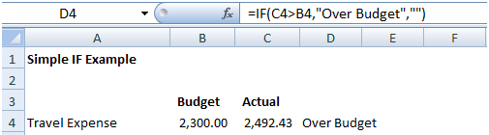

Simple IF with Calculation – Presented below is an example that is a little more complex:

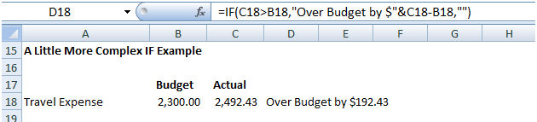

Simple IF – Larger Example - Presented below is yet another IF example on a little larger scale – this example shows how one might apply the IF function to evaluate budget versus actual comparisons.

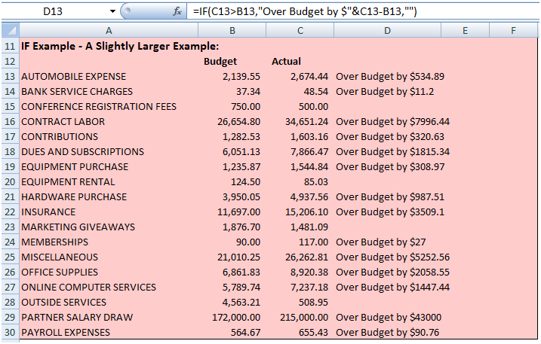

Simple IF with Drop Down - In the following example, the IF function is checking to see if they have signed up for insurance. If they have, the deduction amount is entered.

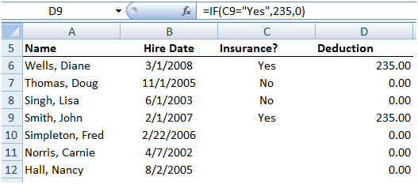

Simple IF with Calculation - The next IF function example is determining each employees earned vacation days. If they have worked for more than a year, they have earned 5 vacation days plus one day for each additional full year.

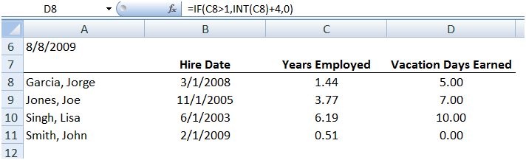

Nested IF Functions - In this sample, there are four possibilities for bonuses.

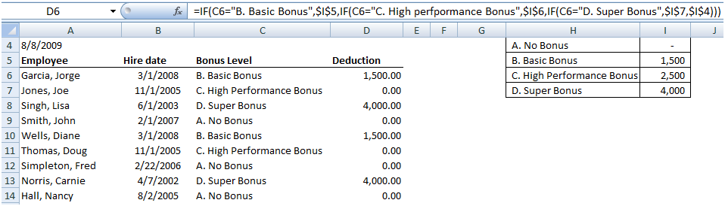

IF Function with Logical OR Argument - Teams A and C meet on Tuesday, Teams B and D meet on Thursday. We want to list the meeting days in column D.

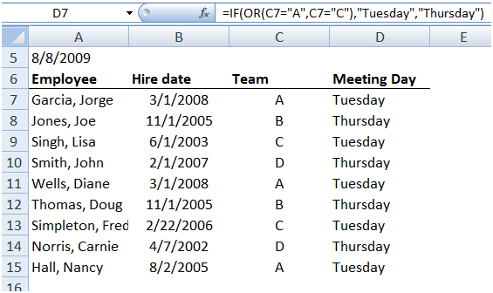
More Complex IF Function Example - The following IF example shows a more complex application in which the user selects a taxpayer status from a drop down list, which then retrieves the correct tax base, threshold, and incremental tax rates to be used in calculating tax.

This example illustrates how a CPA might prepare an income statement template that calculates the appropriate amount of taxes as net income and the taxpayer status changes. Essentially the template calculates the correct tax given all four possible taxpayer statuses, and the IF statements are used to select the correct answers based on the taxpayer status selected.

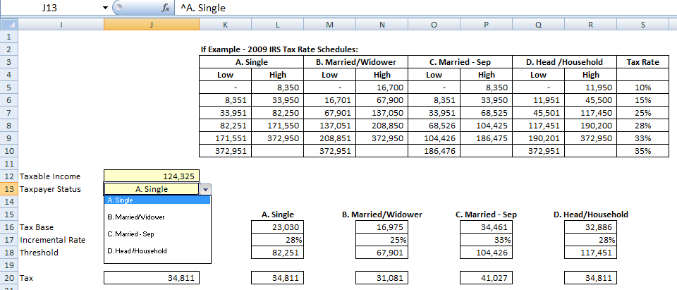

Keep in mind that despite the many accolades mentioned above, the IF Function is not always the best solution. For example, the VLOOKUP would be a better and easier function to use to extract data from a list as shown in the nested IF Function a few examples above. Many Excel Functions also provide built-in “IF-Then-Else” functionality.

Key Pointers for Using the IF Function:

- Nesting – You can embed up to 8 nested IF functions in a single formula in Excel 2003, and up to 64 IF nested functions in Excel 2007.
- AND, OR – You can use the AND and/or OR operator to add more conditions to an IF Function.
- Variations of IF - Excel offers several variations of the IF function as follows: COUNTIF, COUNTIFS, SUMIF, SUMIFS.
- Evaluating an IF Error – Since the IF statement provides only a true or false result, there is no way to evaluate an IF Function to ERROR. If you receive an error, you wrote the formula wrong.
- The Null Set - The Double Quotes is the Null Set, or absence of a value. For example, when testing for a Zero balance or testing for a blank cell, the following IF functions would apply:
  - =IF(A1=0,”ZERO”,””)
  - =IF(A1=””,”Blank”,””)
(Excel also provides an ISBLANK Function that would also work.)

Chapter 3

Using Functions To Crunch & Clean Data

Cleaning Data Using Functions

CPAs often receive or retrieve data from many sources in a wide variety of formats such as Text or CSV formats. You don't always have control over the format and type of data that you import from an external data source, such as a database, text file, or a Web page. Before you can analyze the data, you often need to clean it up. Fortunately, Office Excel has many features to help you get data in the precise format that you want. Sometimes, the task is straightforward and there is a specific feature that does the job for you.

For example, you can easily use Spell Checker to clean up misspelled words in columns that contain comments or descriptions. Or, if you want to remove duplicate rows, you can quickly do this by using the Remove Duplicates dialog box. At other times, you may need to manipulate one or more columns by using a formula to convert the imported values into new values.

For example, if you want to remove trailing spaces, you can create a new column to clean the data by using a formula, filling down the new column, converting that new column's formulas to values, and then removing the original column. Excel provides many functions to help you clean your data as follows:

- Import
- Text to Columns
- Remove Duplicates
- Find & Replace
- Spell Check
- =UPPER
- =LOWER
- =PROPER
- =FIND
- =SEARCH
- =LEN
- =SUBSTITUTE
- =REPLACE
- =LEFT
- =MID
- =RIGHT
- =VALUE
- =CONCATENATE
- =TEXT
- =TRIM
- =CLEAN
- =FIXED
- =DOLLAR
- =CODE
- Macros

- Importing Data into Excel – Of course excel opens up excel files, but what happens when you attempt to open data that is not contained in an Excel format? The answer is that Excel automatically imports that data on the fly and displays a Import Wizard to help you complete the process. The Text Import Wizard examines the text file that you are importing and helps you import the data the way that you want. To start the Text Import Wizard, on the Data tab, in the Get External Data group, click From Text. Then, in the Import Text File dialog box, double-click the text file that you want to import. The following dialog box will be displayed:

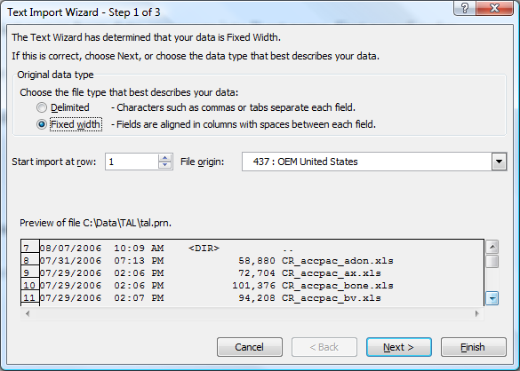

If items in the text file are separated by tabs, colons, semicolons, spaces, or other characters, select Delimited. If all of the items in each column are the same length, select Fixed width. In step 3, click the Advanced button to specify that one or more numeric values may contain a trailing minus sign. Also click the desired data format for each column to be imported.

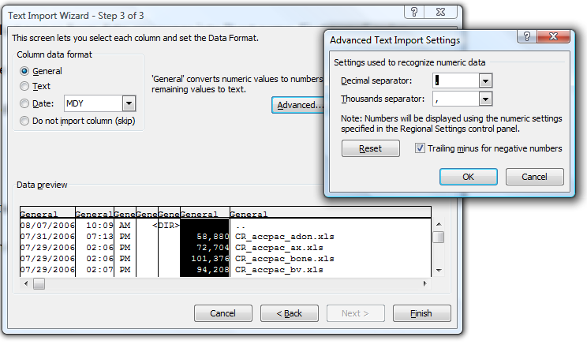

- Text to Columns – The Text to Columns command located on the Data Ribbon works exactly the same way as described above – the user simply launches it to convert data within an existing worksheet.

- Removing Duplicate Rows - Duplicate rows are a common problem when you import data. You can identify and remove duplicate rows by using the Data, Advanced Filter, Unique Records Only tool as show in the screen below.

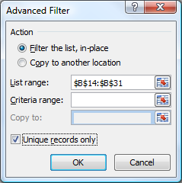

- Find and Replace Text – This tool can be used to identify and remove leading string, such as a label followed by a colon and space, or a suffix, such as a parenthetic phrase at the end of the string that is obsolete or unnecessary. You can do this by finding instances of that text and then replacing it with no text or other text.

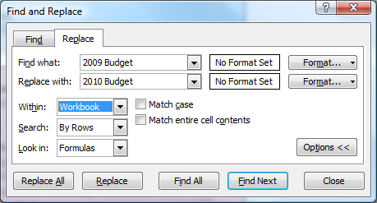

Noteworthy Find and Replace Points:

- You can search and replace for an entire worksheet, or the entire workbook.
- You can find and replace formats with new formats.
- There is a cell chooser option that makes it easier to find and replace formats.
- If you highlight a range of cells, then search and replace only searches and replaces within that range of cells.
- You can replace all at once or one at a time.
- You could also find and replace references in a formula.

- Spell Check - You can use a spell checker to not only find misspelled words, but to find values that are not used consistently, such as product or company names, by adding those values to a custom dictionary. The spell check function also checks your grammar as well.

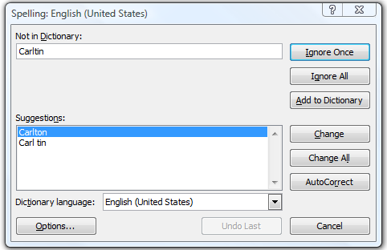

Changing The Case Of Text – You can use one or more of the three Case functions to convert text to lowercase letters, such as e-mail addresses, uppercase letters, such as product codes, or proper case, such as names or book titles.

- = UPPER - Converts text to uppercase letters.

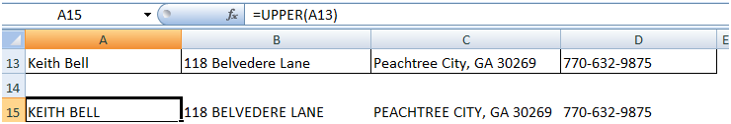

- =LOWER - Converts all uppercase letters in a text string to lowercase letters.

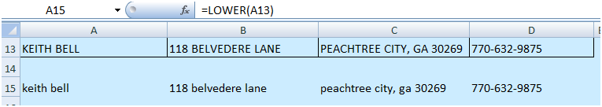

- =PROPER - Capitalizes the first letter in a text string and any other letters in text that follow any character other than a letter. Converts all other letters to lowercase letters.

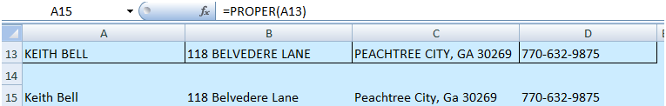

Merging And Splitting Columns - A common task after importing data from an external data source is to either merge two or more columns into one, or split one column into two or more columns. For example, you may want to split a column that contains a full name into a first and last name. Or, you may want to split a column that contains an address field into separate street, city, region, and postal code columns. The reverse may also be true. Presented below are functions that to help you accomplish these tasks:

- =FIND – Use Returns the starting position of a character, string of characters or word with a cell. Find is case sensitive.

- =SEARCH – Returns the starting position of a character, string of characters or word with a cell. Search is not case sensitive.

- =LEN – Displays the length or number of characters in a cell.

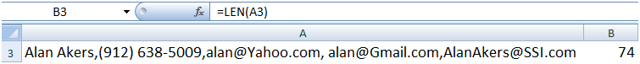

- =SUBSTITUTE – Replaces a character or characters with a character or characters that you specify.
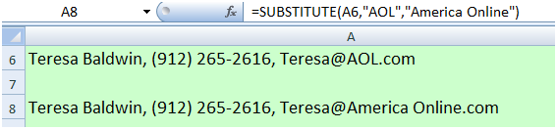

- =REPLACE - Replaces a character or characters with a character or characters that you specify.

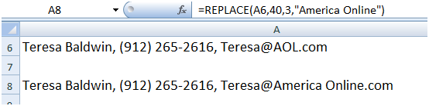

- =LEFT – Extracts the specified number of characters from a cell, starting from the left.

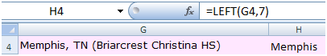

- =MID – Extracts the specified number of characters from a cell, starting from somewhere in the middle of the cell.

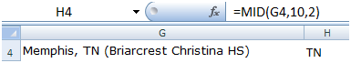

- =RIGHT – Extracts the specified number of characters from a cell, starting from the right.

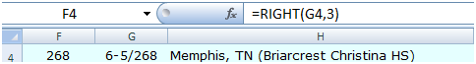

- =Value – Converts text to values so the data can be added, subtracted, multiplied, divided or referenced in a function.

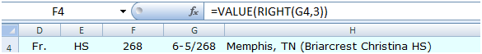

- =CONCATENATE - Joins two or more text strings into one text string.

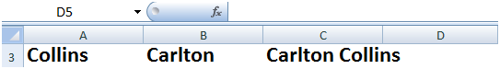

Variations of these functions that are used when working with foreign languages:

=FINDB – Use this when working with foreign characters like these (",")
=SEARCHB – Use this when working with foreign characters like these (",")
=REPLACEB – Use this when working with foreign characters like these (",")
=LEFTB – Use this when working with foreign characters like these (",")
=RIGHTB – Use this when working with foreign characters like these (",")
=LENB – Use this when working with foreign characters like these (",")
=MIDB – Use this when working with foreign characters like these (",")

Cleaning Text – (Removing Spaces And Nonprinting Characters From Text) - Sometimes text values contain leading, trailing, or multiple embedded space characters (Unicode character set values 32 and 160), or nonprinting characters (Unicode character set values 0 to 31, 127, 129, 141, 143, 144, and 157). These characters can sometimes cause unexpected results when you sort, filter, or search. For example, in the external data source, users may make typographical errors by inadvertently adding extra space characters, or imported text data from external sources may contain nonprinting characters that are embedded in the text. Because these characters are not easily noticed, the unexpected results may be difficult to understand. Following is a list of functions you can use to remove these unwanted characters:

- =TEXT - Converts a value to text in a specific number format.

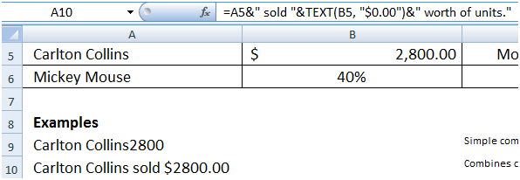

- =TRIM - Removes the 7-bit ASCII space character (value 32) from text.

- =CLEAN - Removes the first 32 nonprinting characters in the 7-bit ASCII code (values 0 through 31) from text.

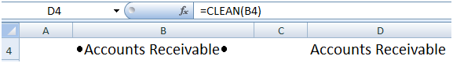

- =FIXED - Rounds a number to the specified number of decimals, formats the number in
decimal format by using a period and commas, and returns the result.

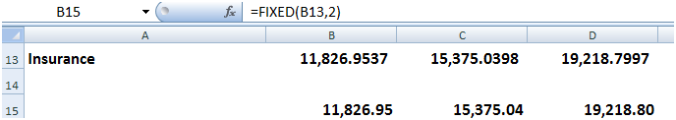

- =DOLLAR - Converts a number to text format and applies a currency symbol.

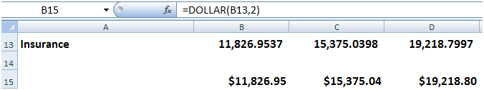

- =CODE - Returns a numeric code for the first character in a text string.

Fixing Dates and Times - There are many different date formats, and these varied formats may be confused with numbered part codes or other strings that contain slash marks or hyphens, dates and times often need to be converted and reformatted. Presented below is a list of functions that help you accomplish this task.

- =DATE - Returns the sequential serial number that represents a particular date. If the cell format was General before the function was entered, the result is formatted as a date.

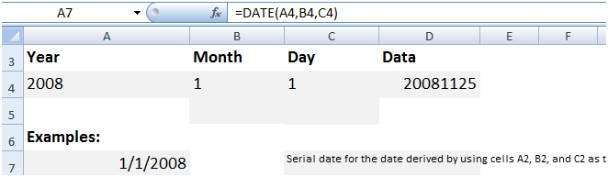

- =DATEVALUE - Converts a date represented by text to a serial number.

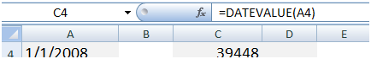

- =TIME - Returns the decimal number for a particular time. If the cell format was General before the function was entered, the result is formatted as a date.

- =TIMEVALUE - Returns the decimal number of the time represented by a text string. The decimal number is a value ranging from 0 (zero) to 0.99999999, representing the times from 0:00:00 (12:00:00 AM) to 23:59:59 (11:59:59 P.M.).

Transforming And Rearranging Columns And Rows - Most of the analysis and formatting features in Office Excel assume that the data exists in a single, flat two-dimensional table. Sometimes you may want to make the rows become columns, and the columns become rows. At other times, data is not even structured in a tabular format, and you need a way to transform the data from a nontabular to a tabular format. The following function can help you achieve this goal:

- =TRANSPOSE - Returns a vertical range of cells as a horizontal range, or vice versa.

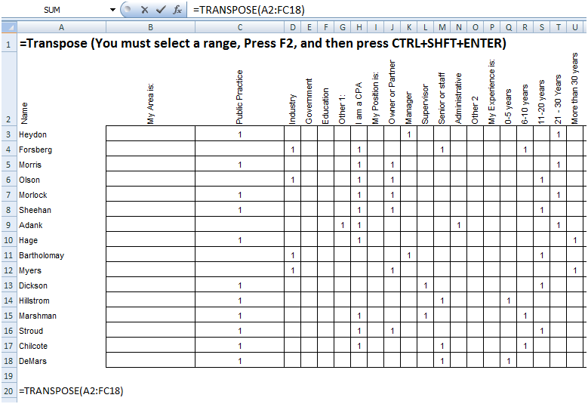

- Data Fill In Trick – A clever trick for filling in missing data can be accomplished using the GOTO, Special, Blanks command. Here is how it works. This trick works well when you have a large volume of data but descriptions are not provided for every row, as shown in the example below:

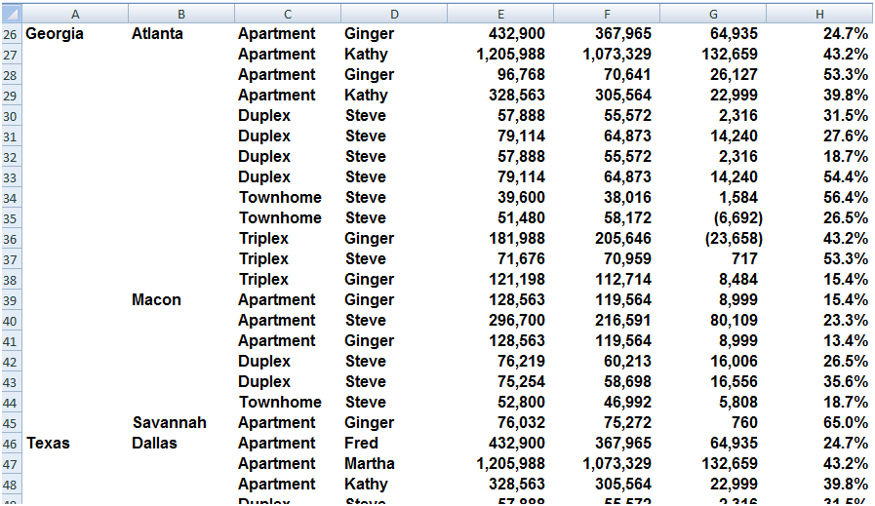

Start by entering a simple formula referencing the data label in the above cell, just like this:

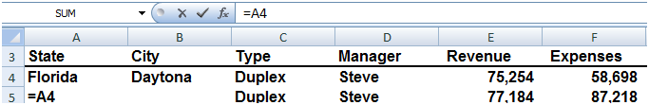

  - Next copy that formula...
  - Highlight the entire range containing data labels in columns A and B. columns...
  - Press the F5 key to launch the GoTo dialog box...
  - Select the Options Box...
  - Click on the “Blanks” radio button...
  - Press Enter...
  - Paste.

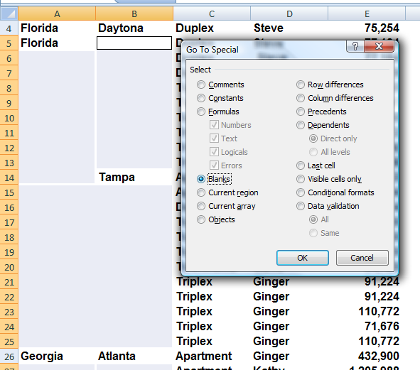

This action will cause all data labels to repeat in the empty cells beneath. Next:

  - Copy columns A & B...
  - Paste Special as values to convert the formulas to text based data labels...
  - You are now ready to sort, filter, subtotal and pivot your data.

Fetching Data - Occasionally, database administrators use Office Excel to find and correct matching errors when two or more tables are joined. This might involve reconciling two tables from different worksheets, for example, to see all records in both tables or to compare tables and find rows that don't match.

- =VLOOKUP - Searches for a value in the first column of a table array and returns a value in the same row from another column in the table array. For example, consider the example below which uses a =VLOOKUP function to calculate the appropriate amount of tax due based on the IRS rate schedule.

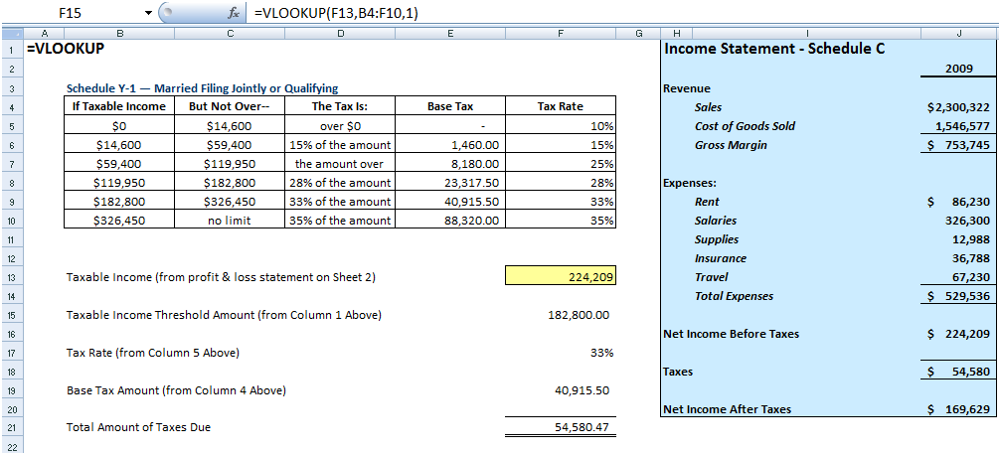

As the Income statement shown in the shaded area is updated , the resulting taxable income amount is referenced in Cell F13. Next, 3 VLOOKUP functions pull the appropriate rate, base and threshold information from the rate schedule to be used in calculating income tax. Once calculated, the resulting tax is referenced back to the income statement for the purposes of computing Net income After taxes.

Key points to Consider when Using VLOOKUP:

  - If you are looking up based on text, the first column containing lookup values must be sorted alphabetically in descending order – else it will not work properly.

  - If you are looking up based on text, you must have an exact match between the lookup value and the table array value.

  - If you are looking up based on values, the first column containing lookup values must be sorted numerically in descending order – else it will not work properly.

  - If you are looking up based on values, then Excel will choose the closest value without going over. For example, if the lookup value is 198,000 and the table array contains values of 100,000 and 200,000, the n excel will choose 100,000 because 200,000 goes over or exceeds 198,000. (It might be helpful to think back to the old Bob barker game show the Price is Right.)



- =HLOOKUP - Searches for a value in the top row of a table or an array of values, and then returns a value in the same column from a row you specify in the table or array.

- =INDEX - Returns a value or the reference to a value from within a table or range. There are two forms of the INDEX function: the array form and the reference form.

- =MATCH - Returns the relative position of an item in an array that matches a specified value in a specified order. Use MATCH instead of one of the LOOKUP functions when you need the position of an item in a range instead of the item itself.

- =OFFSET - Returns a reference to a range that is a specified number of rows and columns from a cell or range of cells. The reference that is returned can be a single cell or a range of cells. You can specify the number of rows and the number of columns to be returned.

- Data Cleaning with Macros - To periodically clean the same data source, consider recording a macro or writing code to automate the entire process. There are also a number of external add-ins written by third-party vendors, listed in the Third-party providers section, that you can consider using if you don't have the time or resources to automate the process on your own.

RAND( ), RANDBETWEEN( ), ROUND( ) – In Excel 2003, RANDBETWEEN is not in the standard EXCEL installation but if the analysis tool pack is installed and the add-in activated it is an extremely useful function.

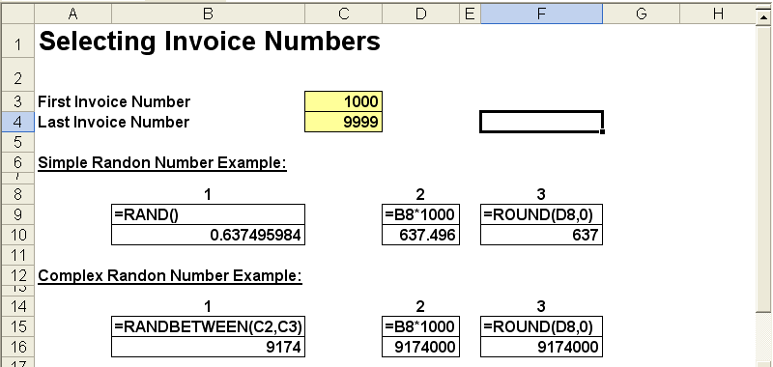

Informational Functions
CELL(info_type,reference) - Info_type is a text value that specifies what type of cell information you want. The following list shows the possible values of info_type and the corresponding results.
Info_type | Returns
"address" | Reference of the first cell in reference, as text.
"col" | Column number of the cell in reference.
"color" | 1 if the cell is formatted in color for negative values; otherwise returns 0 (zero).
"contents" | Value of the upper-left cell in reference; not a formula.
"filename" | Filename (including full path) of the file that contains reference, as text. Returns empty text ("") if the worksheet that contains reference has not yet been saved.
"format" | Text value corresponding to the number format of the cell. The text values for the various formats are shown in the following table. Returns "-" at the end of the text value if the cell is formatted in color for negative values. Returns "()" at the end of the text value if the cell is formatted with parentheses for positive or all values.
"parentheses" | 1 if the cell is formatted with parentheses for positive or all values; otherwise returns 0.
"prefix" | Text value corresponding to the "label prefix" of the cell. Returns single quotation mark (') if the cell contains left-aligned text, double quotation mark (") if the cell contains right-aligned text, caret (^) if the cell contains centered text, backslash (\) if the cell contains fill-aligned text, and empty text ("") if the cell contains anything else.
"protect" | 0 if the cell is not locked, and 1 if the cell is locked.
"row" | Row number of the cell in reference.
"type" | Text value corresponding to the type of data in the cell. Returns "b" for blank if the cell is empty, "l" for label if the cell contains a text constant, and "v" for value if the cell contains anything else.
"width" | Column width of the cell rounded off to an integer. Each unit of column width is equal to the width of one character in the default font size.
Reference the cell that you want information about. If omitted, information specified in info_type is returned for the last cell that was changed. The following list describes the text values CELL returns when info_type is "format", and reference is a cell formatted with a built-in number format.
If the Microsoft Excel format is | CELL returns
General | "G"
0 | "F0"
#,##0 | ",0"
0.00 | "F2"
#,##0.00 | ",2"
$#,##0_);($#,##0) | "C0"
$#,##0_);[Red]($#,##0) | "C0-"
$#,##0.00_);($#,##0.00) | "C2"
$#,##0.00_);[Red]($#,##0.00) | "C2-"
0% | "P0"
0.00% | "P2"
0.00E+00 | "S2"
# ?/? or # ??/?? | "G"
m/d/yy or m/d/yy h:mm or mm/dd/yy | "D4"
d-mmm-yy or dd-mmm-yy | "D1"
d-mmm or dd-mmm | "D2"
mmm-yy | "D3"
mm/dd | "D5"
h:mm AM/PM | "D7"
h:mm:ss AM/PM | "D6"
h:mm | "D9"
h:mm:ss | "D8"
If the info_type argument in the CELL formula is "format", and if the cell is formatted later with a custom format, then you must recalculate the worksheet to update the CELL formula.

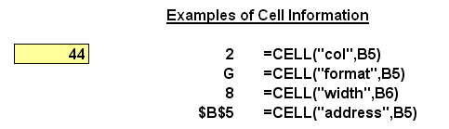

Third-Party Solutions – In case Excels built in functions are not sufficient to meet your needs, following is a partial list of third-party providers that have products that are used to clean data in a variety of ways.

Provider Product
Add-in Express Ltd. Advanced Find & Replace, Merge Cells Wizard
Add-Ins.com Duplicate Finder
AddinTools AddinTools Assist
CDX Zip Stream
Click 2 Convert Converts PDF to Excel formats
DigDB Add-ins for Excel®
JKP Application Development Flexfind for Excel
J-Walk & Associates, Inc. Power Utility Pak Version 7
Office Assistance LLC Similar Data Finder for Excel®
PATools PATools Advanced Find Replace
PDF2XL Converts PDF files to Excel Formats
Spinnaker Software Solutions Spinnaker DB tools for Excel
Vonnix Excel Power Expander 4.6
WinPure ListCleaner Lite
ListCleaner Pro
Clean and Match 2007

Chapter 4
Data Commands
The Heart & Soul Of Excel

The Data Menu - Perhaps the parts of Excel that are of most value to CPAs, but least used by CPAs are the Data commands found under the Data menu in Excel 2003 and earlier, and on the data Ribbon in Excel 2007. These commands are shown below, and we will concentrate the next hour to studying these commands.

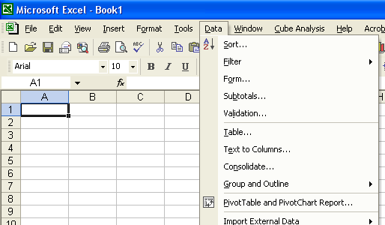

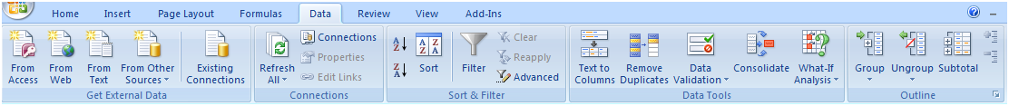

Data Sort - The Sort tool does exactly what it implies – it sorts and data. Key sorting points are as follows:

- Contiguous Data - The “A to Z” sorting tool can sort large matrix of data automatically as long as the data is contiguous. In other words, your data should contain no blank columns, no blank rows, and the columns must all be labeled. Only then will Excel always correctly select the entire matrix for sorting.

- A to Z Button - Simply place the cursor in the desired column for sorted, and press the A to Z or Z to A button as the case may be. Excel will automatically sort all continuous columns that have headings and all contiguous rows from the top row under the heading labels down to the last row in the selected column that contains data. (Note - If you accidently select 2 cells instead of just one, your results will not be correct.)

- Sort by 64 Columns - The “Sort” tool is dramatically enhanced in Excel 2007 as it now provides the ability to sort by up to 64 columns, instead of just 3 columns. Presented below is a dialog box which shows this expanded functionality.

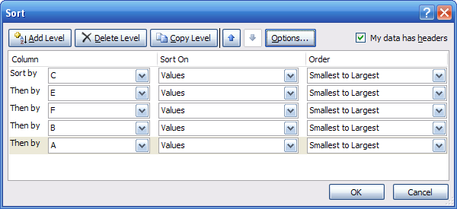

- Sort Left to Right – Excel has always provided the ability to sort left to right. To do so, select the options box in the Sort Dialog box and click the check box labeled “Sort left to Right” as shown below.

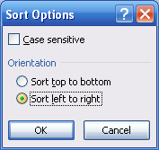

- Sort by Color – Excel 2007 now provides the ability to sort by font color or by cell color, or both. This is handy in many ways. Sometimes CPAs use color to tag or mark certain cells - and later find it useful to be able to sort by those markings. In other situations CPAs use conditional formatting to apply color to cells using a wide variety of rules. Thereafter Excel can sort the data based on the resulting colors. The sort-by-color options are shown below.

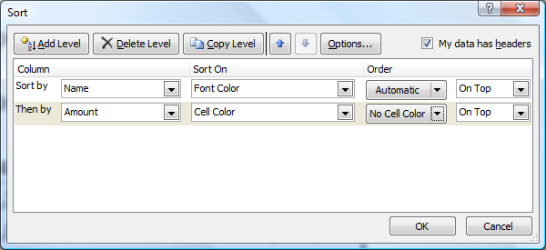

To be accurate, it was possible to sort by color in Excel 2003. To accomplish this task, you needed to use the =CELL function in order to identify information about a given cell such as the cell color or font color. Thereafter, the results of that function could be used to sort rows – which effectively means that you can sort by color in Excel 2003 – but it takes a bit more effort.

- Sort By Custom List – Another sorting capability in Excel is the ability to sort by Custom List. For example, assume a CPA firm has ten partners, and the Managing partner prefers to be shown at the top of the list, and the remaining Partners based on seniority. In this case, you could create a Custom List in the excel Options dialog box listing the partners in the desired order, and then sort future reports based on that order.

Perhaps a better example use of this feature would be to create a non-alphabetic custom list of your chart of accounts, and then sort transactions to produce a general ledger in chart of account order – even if your preferred chart of accounts is not alphabetical. the partner seniority does not match the alphabetic names, nor any

Filtering Data - Using AutoFilter to filter data allows you to view a subset of your data in a range of cells or table. Once you have filtered the data, you can apply additional filters to further refine your data view. When you are done, you can clear a filter to once again redisplay all of the data. To use this tool, start with any list of data and turn on the AutoFilter tool. Then position your cursor in the column you want to filter and use the drop down arrows to apply your filters as shown in the screen below.

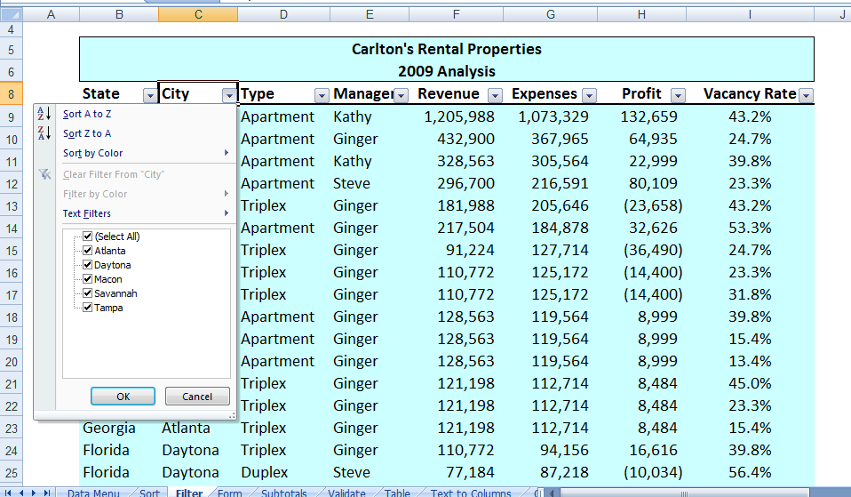

Once the filters are applied, you will see a subset your data. For example, the screen presented below shows filtered data for only Macon and Savannah properties.

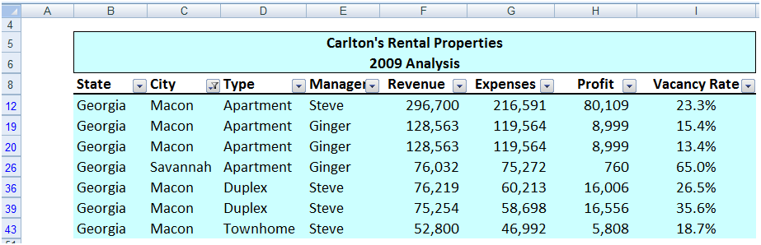

As filters are applied, a small funnel appears in the drop down arrow button to indicate that a filter has been applied. You can apply filters for multiple columns simultaneously.

Key Points Concerning The AutoFilter Command:

- Contiguous Data – The AutoFilter tools works best when you are working with data that is contiguous. In other words, your data should contain no blank columns, no blank rows, and the columns must all be labeled.

- Filter by Multiple Columns - You can filter by more than one column.

- Removing Filters – In Excel 2003 and earlier, a faster way to remove multiple filters is to turn off filtering and then turn filtering back on. In Excel 2007 you can simple click the Clear button in the Sort and Filter Group as shown below.

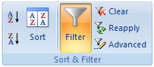

- Filters are Additive - Each additional filter is based on the current filter and further reduces the subset of data.

- Three Types of Filters – You can filter based on list values, by formats, or by criteria. Each of these filter types is mutually exclusive for each range of cells or column table. For example, you can filter by cell color or by a list of numbers, but not by both; you can filter by icon or by a custom filter, but not by both.

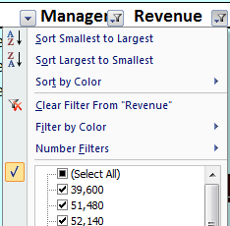
- Filters Enabled - A drop-down arrow means that filtering is enabled but not applied.

- Filter Applied - A Filter button means that a filter is applied.

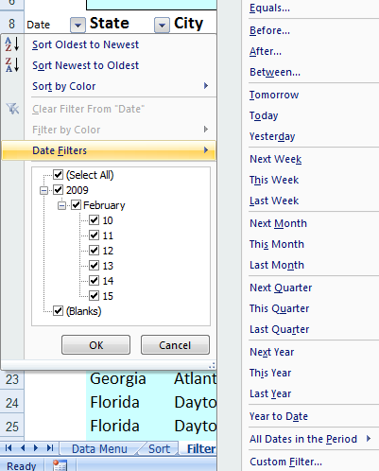
- Filter Spanning - The commands under the All Dates in the Period menu, such as January or Quarter 2, filter by the period no matter what the year. This can be useful, for example, to compare sales by a period across several years.

- This Year vs. Year-to-Date Filtering - This Year and Year-to-Date are different in the way that future dates are handled. This Year can return dates in the future for the current year, whereas Year to Date only returns dates up to and including the current date.

- Filtering Dates - All date filters are based on the Gregorian calendar as decreed by Pope Gregory XIII, after whom the calendar was named, on 24 February 1582. The Gregorian calendar modifies the Julian calendar's regular four-year cycle of leap years as follows: Every year that is exactly divisible by four is a leap year, except for years that are exactly divisible by 100; the centurial years that are exactly divisible by 400 are still leap years. For example, the year 1900 is not a leap year; the year 2000 is a leap year.

- Filtering By Days of Week - If you want to filter by days of the week, simply format the cells to show the day of the week.
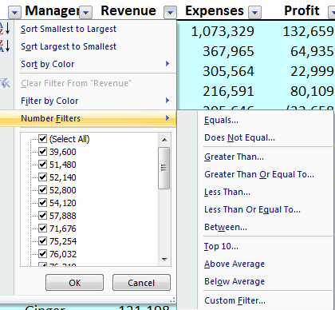
- Top & Bottom Filtering - On the Data tab, in the Sort & Filter group, click Filter. Point to Number Filters and then select Top 10. To filter by number, click Items. To filter by percentage, click Percent. Note - Top and bottom values are based on the original range of cells or table column and not the filtered subset of data.

- Above & Below Average Filtering - On the Data tab, in the Sort & Filter group, click Filter. Point to Filter by Numbers that are Above/Below Average. Note – These values are based on the original range of cells or table column and not the filtered subset of data.

- Filtering Out Blanks - To filter for blanks, in the AutoFilter menu at the top of the list of values, clear (Select All), and then at the bottom of the list of values, select (Blanks).

- Filtering By Color - Select Filter by Color, and then depending on the type of format, select Filter by Cell Color, Filter by Font Color, or Filter by Cell Icon.

- Filter by Selection - To filter by text, number, or date or time, click Filter by Selected Cell's Value and then: To filter by cell color, click Filter by Selected Cell's Color. To filter by font color, click Filter by Selected Cell's Font Color. To filter by icon, click Filter by Selected Cell's Icon.

- Refreshing Filters - To reapply a filter after the data changes, click a cell in the range or table, and then on the Data tab, in the Sort & Filter group, click Reapply.

Data Form – Excel’s 2003 Data Form tool makes Excel look more and behave more like a database, such as Microsoft Access. (The Form button has not been included on the Office Fluent user interface Ribbon, but you can still use it in Office Excel 2007 by adding the Form button to the Quick Access Toolbar.)

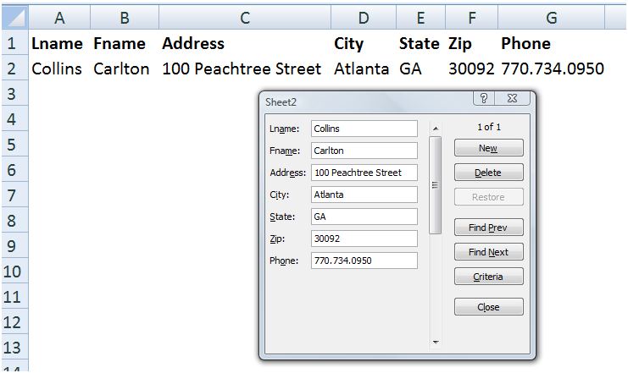

A data form provides a convenient means to enter or display one complete row of information in a range or table without scrolling horizontally. You may find that using a data form can make data entry easier than moving from column to column when you have more columns of data than can be viewed on the screen. Use a data form when a simple form of text boxes that list the column headings as labels is sufficient and you don't need sophisticated or custom form features, such as a list box or spin button.

Key Points using data Form:

- You cannot print a data form.

- Because a data form is a modal dialog box, you cannot use either the Excel Print command or Print button until you close the data form.

- You might consider using the Windows Print Screen key to make an image of the form, and then paste it into Microsoft Word for printing.

Data Subtotals – Excel provides an automatic subtotaling which will automatically calculate and insert subtotals and grand totals in your list or table. Once inserted, Excel recalculates subtotal and grand total values automatically as you enter and edit the detail data. The Subtotal command also outlines the list so that you can display and hide the detail rows for each subtotal. Examples of a the Subtotal dialog box and a resulting subtotaled table are shown below.

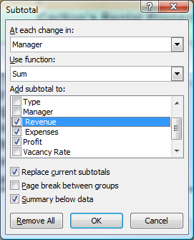

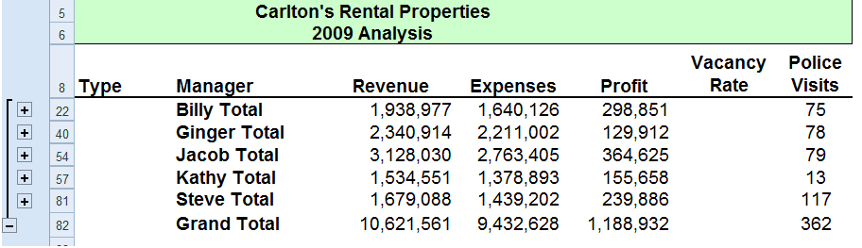

Key points to Consider When Using Subtotaling are as follows:

- Contiguous Data – The Subtotal tools works best when you are working with data that is contiguous. In other words, your data should contain no blank columns, no blank rows, and the columns must all be labeled.

- Sort Before Your Subtotal - You must sort the data by the column you wish to Subtotal by, else you will receive erroneous results.

- Other Mathematical Applications - The Subtotal tool not only calculates subtotals, but it can also calculate minimums, maximums, averages, standard deviations, and other functions.

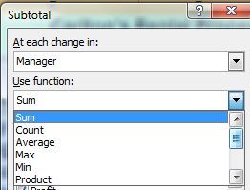

- Subtotals in 2007 Tables – Excel 2007 deploys Subtotaling a little differently in that the Subtotal tool appears at the bottom of each column in each table, as shown in the screen below.

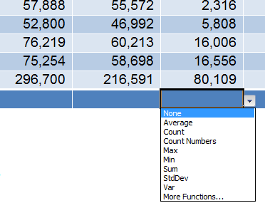

- Automatic Outlining - Subtotaling automatically inserts Outlines, which is really cool. You can then condense and expand the data in total and by subtotal. Some CPAs also like to copy and paste the condensed subtotal information to another location but find that this process copies and pastes all of the data. There are two ways to achieve a clean copy and paste without grabbing all the hidden data as follows:
  - CTRL key – Hold the Control Key down while you individually click on each subtotal row. This will enable you to copy and paste just the subtotal data. This approach can be problematic because if you mis-click, you have to start over.

  - Select Visible Cells – A better approach is to use the Select Visible Cells tool. This tool will select on the data you can see, after which the copy and paste routine will yield the desired results. This option is better because it is faster and less error prone.

Data Validation

Data Validation can be used to limit the data that can be entered into a cell. For example, you might want the user to enter only values between 1% and 99%. You might also use this tool to enable data input to a drop down list. This has two advantages in that it can be faster and more accurate. Start with the dialog box below to create your drop down list functionality.

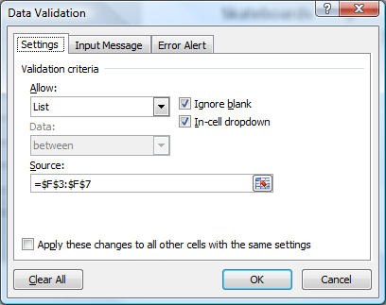

After making all the necessary selections in the validation list dialog box, your worksheet will behave as shown below.

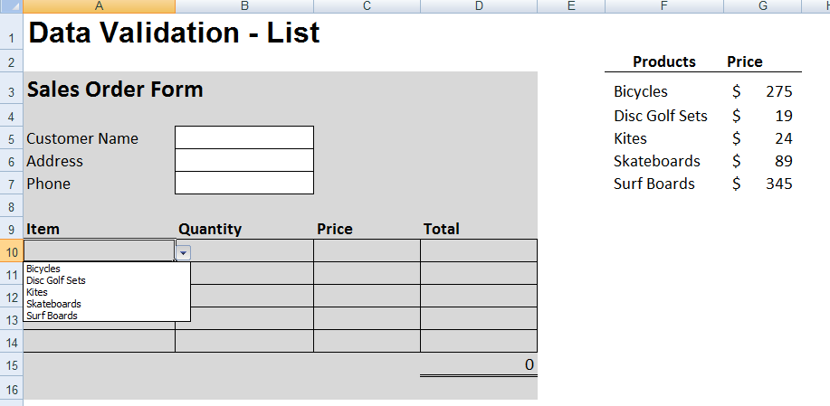
You can also provide messages to define what input you expect for the cell, and instructions to help users correct any errors. For example, in a marketing workbook, you can set up a cell to allow only account numbers that are exactly three characters long. When users select the cell, you can show them a message such as this one:

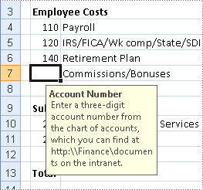

If users ignore this message and type invalid data in the cell, such as a two-digit or five-digit number, you can show them an actual error message. In a more advanced scenario, you might use data validation to calculate the maximum allowed value in a cell based on a value elsewhere in the workbook. In the following example, the user has typed $4,000 in cell E7, which exceeds the maximum limit specified for commissions and bonuses.

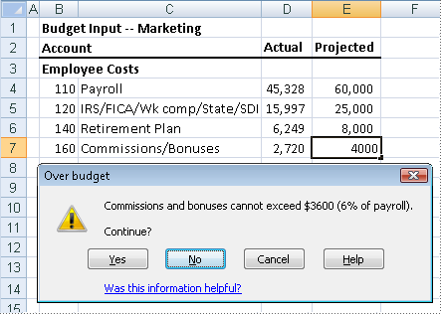

If the payroll budget were to increase or decrease, the allowed maximum in E7 would automatically increase or decrease with it.

PivotTables

The PivotTable report tool provides an interactive way to summarize large amounts of data. Use should use the PivotTable tools to crunch and analyze numerical data PivotTable reports are particularly useful in the following situations:

- Rearranging rows to columns or columns to rows (or "pivoting") to see different summaries of the source data.
- Filtering, sorting, grouping, and conditionally formatting your data.
- Preparing concise, attractive, and annotated online or printed reports
- Querying large amounts of data.
- Subtotaling and aggregating numeric data.
- Summarizing data by categories and subcategories
- Creating custom calculations and formulas.
- Expanding and collapsing levels of data.
- Drilling down to details from the summary data

In essence, PivotTables present multidimensional data views to the user – this process is often referred to as “modeling”, “data-cube analysis”, or “OLAP data cubes”. To re-arrange the PivotTable data, just drag and drop column and row headings to move data around. PivotTables are a great data analysis tool for management.

If you have never used a PivotTable before, initially the concept can be difficult to grasp. The best way to understand a PivotTable is to create a blank Pivot Table and then drag and drop field names onto that blank table. This way you will see the resulting pivot table magically appear and it will help you better understand the important relationship between the pivot pallet and the field name list.

Let’s create a simple PivotTable. Start with an Excel worksheet data that contains several columns of data – the data must include column and row headings and it helps if the data is contiguous. Place your cursor anywhere in the data and select PivotTable from the Data menu in Excel 2003 and click Finish; or from the insert Ribbon in Excel 2007. This process is shown below: Let’s start with a page of data summarizing the results of tax season as all of the time sheet entries have been entered onto a single worksheet as shown below.

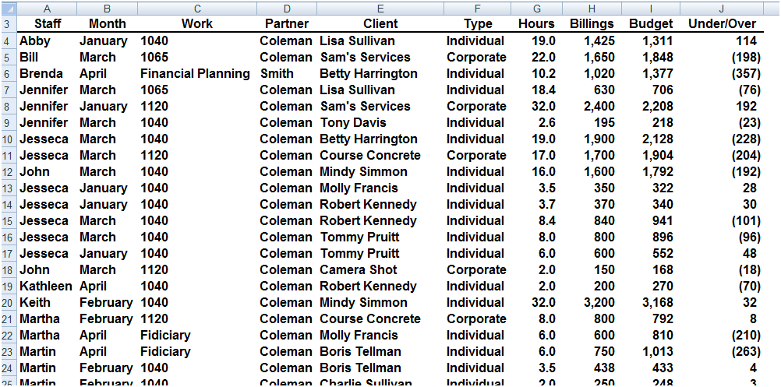

Place your cursor anywhere in the data and select PivotTable from the Insert Ribbon as shown below:

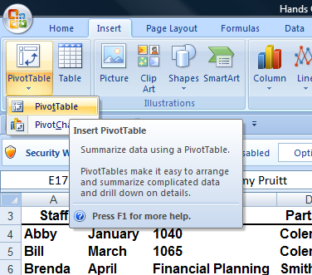

For learning purposes let’s right mouse click on the pivot table and select PivotTable Options, Display, Classic PivotTable Layout. Your screen will now appear as follows:

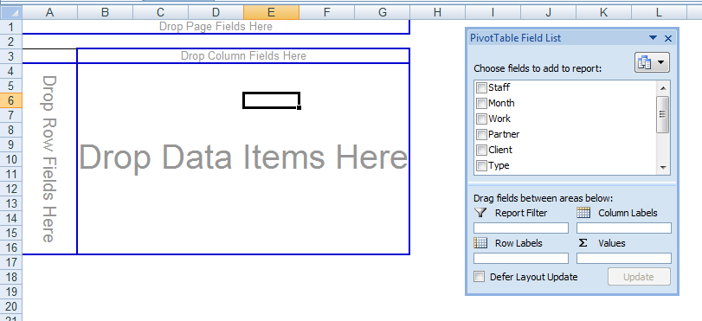

I like for CPAs to learn how to use Pivot Tables in this view because it visually helps them understand the all important relationship better the blank pivot palette and the PivotTable field List, both elements of which are shown in the screen above.

To proceed, simply drag and drop field names shown on the right onto the blank Pivot palette shown on the left. With each drop, your report grows larger. As an alternative you could use the check boxes next to field names – this functionality is new in Excel 2007. After added some data to your blank Pivot Palette, your data will look something like this:

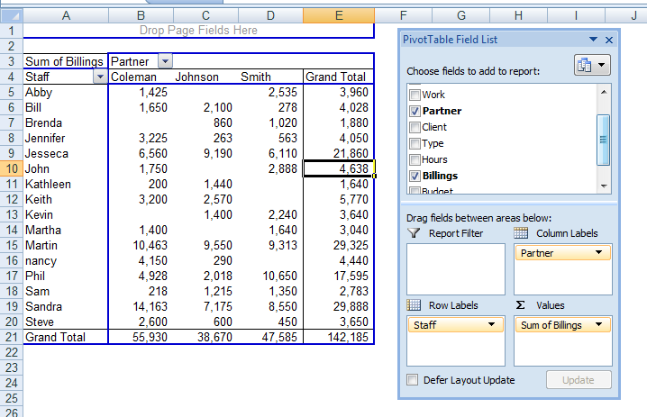

Next format and filter the Pivot Report. Very quickly your report comes together as shown below. Notice the filter button has been applied and a Pivot table style has also been applied for appearance.

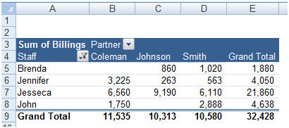

Double clicking on any number in a pivot report will automatically produce a new worksheet complete with all supporting detail that comprises the summary number.

There are a multitude of PivotTable options that can be applied to alter the appearance or behavior of your Pivot table.

Key Points Concerning Pivot Tables are as Follows:

- You can create as many Pivot Reports as you want from your initial raw data page. Your raw data remains unchanged as new Pivot tables are created.

- As your raw data changes, your pivot tables are updated each time you press the refresh button. Or if you prefer you can set your PivotTables to update themselves at regularly scheduled intervals – say every ten minutes.

- A key to understanding PivotTables is understanding the relationship between the Blank Pivot palette and the PivotTable Field list. As data is selected in the list, it appears on the Pivot table Report.

- You can alter the PivotTable simple by dragging and dropping the field names in different locations on the Pivot palette, or in different locations in the PivotTable Field list Box.

- PivotTables can be pivoted.

- PivotTables can be sorted by any Column. (Or by any row when sorting left to right)

- PivotTables can be Filtered.

- PivotTables can be Drilled.

- PivotTables can be copied and pasted.

- PivotTables can be formatted using PivotTable Styles, as shown below.

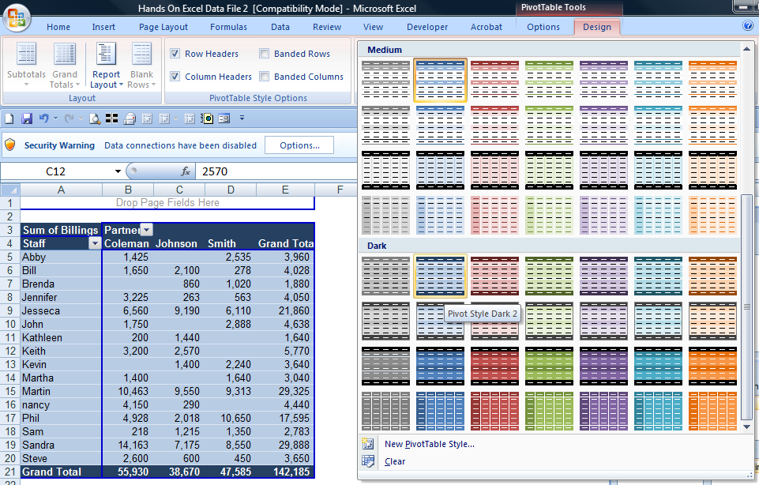

- Subtotals and grand totals can be displayed or suppressed at the users desire.

- PivotTable Data can be shown as numbers or percentages at the users desire.

- PivotTable can not only be summed, it can be averaged, minimized, maximized, counted, etc.

- Blank rows can be displayed or suppressed at the users desire.

- A new feature called “Compact Form” organized multiple column labels into a neatly organized outline which is easier to read.

- PivotTables can query data directly from any ODBC compliant database. The PivotTable tool for accomplishing this task is not included in the ribbon – you will find it by Customizing the Quick Access Tool Bar and searching the “Commands Not Shown in the Ribbon” tab to find the PivotTable and PivotChart Wizard Option.

- Many accounting systems can push data out of the accounting system into an Excel PivotTable format – this is commonly referred to as an OLAP Data Cube. OLAP data Cube is just a fancy word for PivotTable – and there is no difference.

- PivotTables can automatically combine data from multiple data sources. The PivotTable tool for accomplishing this task is not included in the ribbon – you will find it by Customizing the Quick Access Tool Bar and searching the “Commands Not Shown in the Ribbon” tab to find the PivotTable and PivotChart Wizard Option.

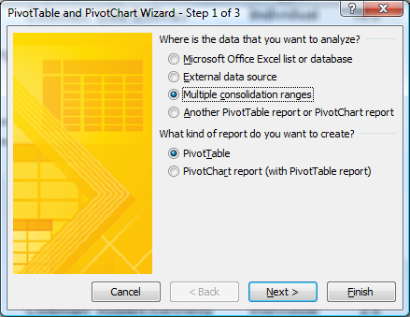

- Excel also provides a PivotChart function which works similarly to PivotTables. Presented below is an example PivotChart.
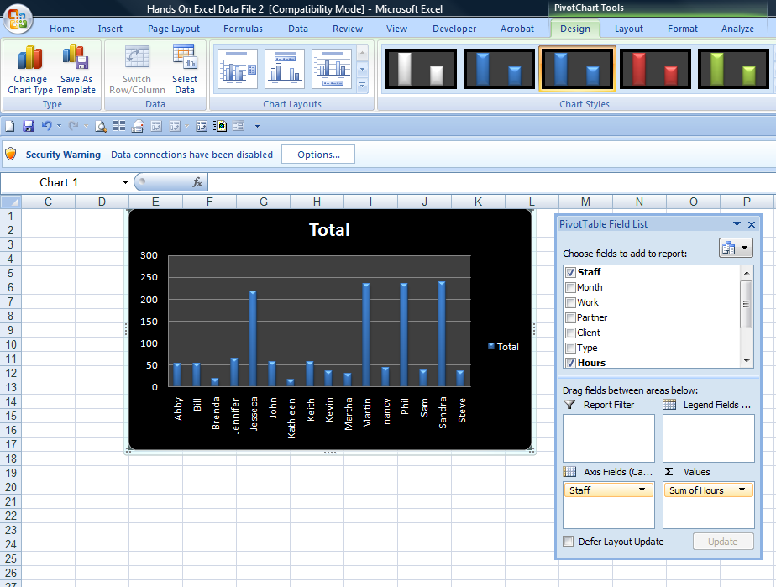

Excel 2003 PivotTables work very similarly as shown below. Excel creates a blank PivotTable, and the user must drag and drop the various fields from the PivotTable Field List onto the appropriate column, row, or data section. As you drag and drop these items, the resulting report is displayed on the fly. Here is the blank Pivot Palette view.

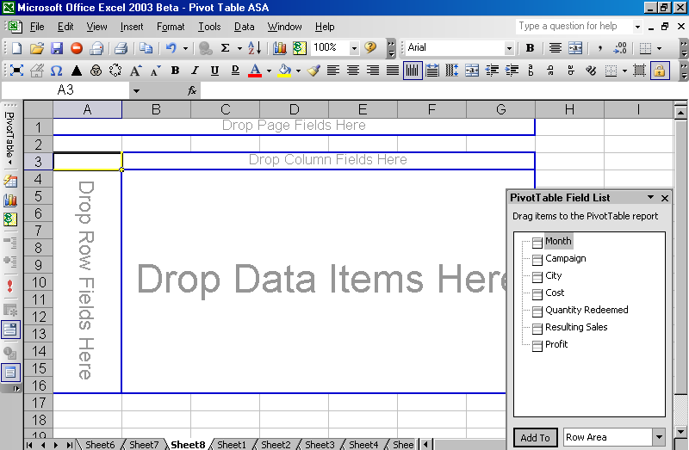

Now drag and drop field names from the Pivot Table field list onto the Pivot pallet. This action will automatically create Pivot Table reports – and they will change each time you drop additional field names, or move field names around. Presented below are but a few examples of hundreds of possible reports that could be viewed with this data through the PivotTable format.

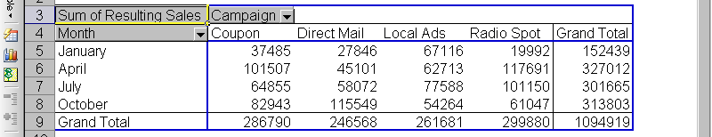

This report shown above shows the total resulting sales for each marketing campaign for each of the 4 months marketing campaigns were conducted.

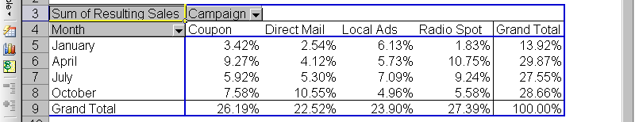

In this screen we see the same information is shown as a percentage of the total. A few observations include the fact that overall Radio Spots are the most profitable type of campaign, but only in April and July. In January and October, local ads and direct mail, respectively, produce better results. Further, April campaigns had the best response overall.

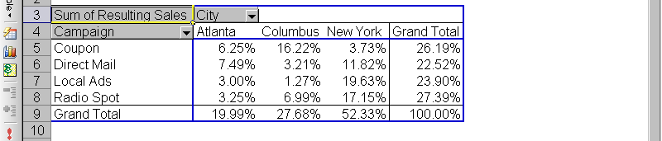

Further analysis in the screen above tells us that our results vary widely from one city to the next. In New York, coupons were least effective, but coupons were most effective in Columbus. Pivot charts based on PivotTable data can be modified by pivoting and/or narrowing the data. They can also be published on the Internet (or on an Intranet) as interactive Web pages. This allows users to “play” with the data. The chart below provides a visual look at the data shown above.

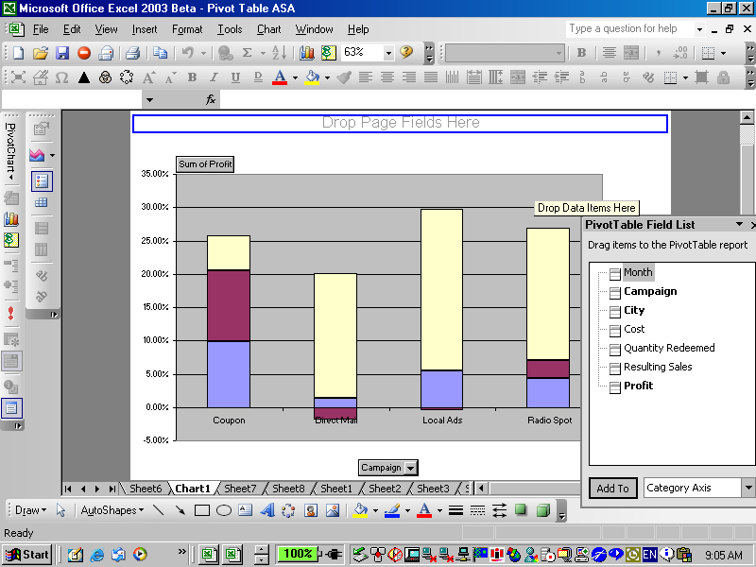

Filtering Pivot Tables - If you take a close look at your resulting pivot tables, you will notice that Excel automatically inserts a filter button on each field list as shown by the drop down arrows in the screen below:

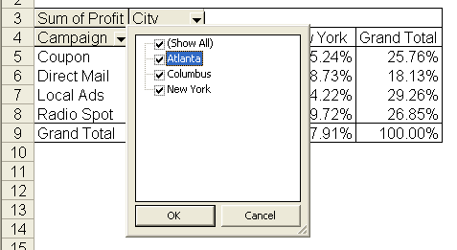

This drop down filter list makes it easy to refine your report to include just the data you want.

Drilling Pivot Tables - Another nice feature in pivot tables is that they are automatically drillable. Simply double click on any number in a pivot report top have Excel automatically insert a new sheet and produce the detailed report underlying the number you clicked on. An example of this is shown below:

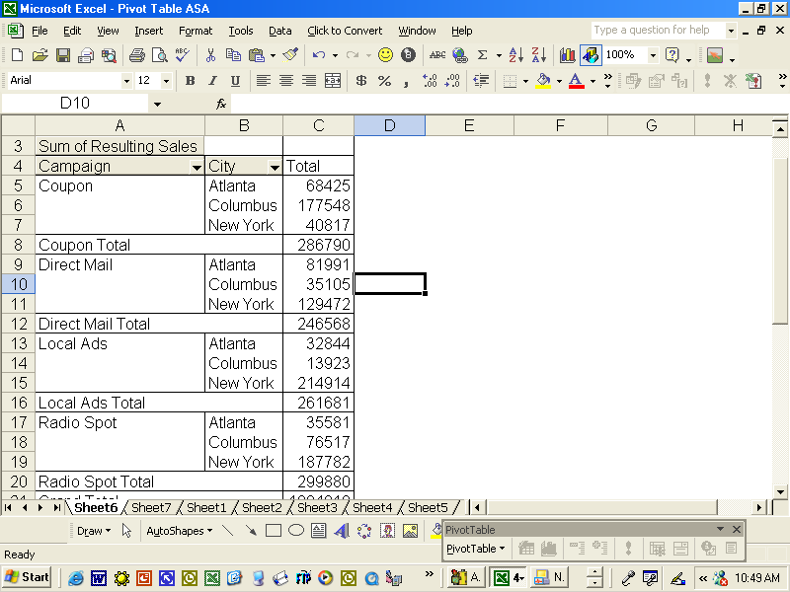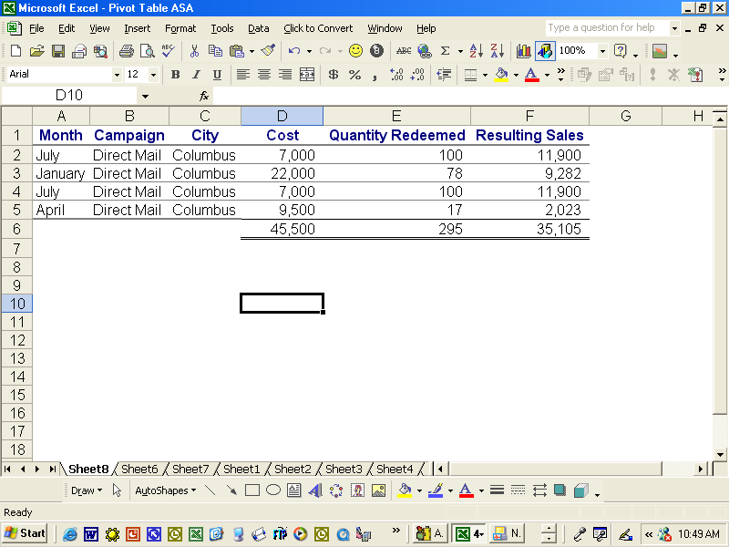

Pivot Table Options - By right mouse clicking on your pivot table you will reveal several option settings boxes as shown below. For example, these options boxes control the types of subtotals produced in your pivot reports. Excel also offers a pivot table options box as well as a layout wizard that makes producing pivot tables a little easier.
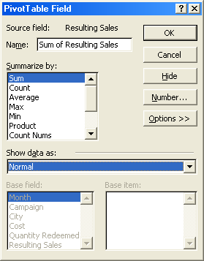
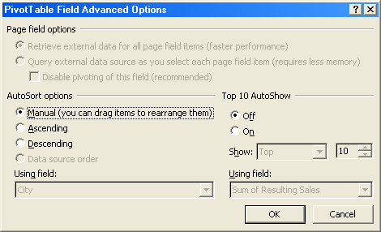
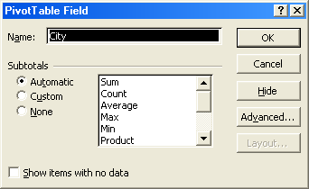

Data Table (“What-if Analysis”)

Data tables are part of a suite of commands that are called what-if analysis tools. When you use data tables, you are doing “what-if analysis”. What-if analysis is the process of changing the values in cells to see how those changes will affect the outcome of formulas on the worksheet. For example, you can use a data table to vary the interest rate and term length that are used in a loan to determine possible monthly payment amounts.

Three categories of What-if Analysis Tools - There are three kinds of what-if analysis tools in Excel:

- Data Tables
- Goal Seek
- Scenarios

A data table cannot accommodate more than two variables. If you want to analyze more than two variables, you should instead use scenarios. Although it is limited to only one or two variables (one for the row input cell and one for the column input cell), a data table can include as many different variable values as you want. A scenario can have a maximum of 32 different values, but you can create as many scenarios as you want.

Loan Analysis - In this exercise, we start by creating a simple Payment function to calculate the payment amount of a loan given a loan amount, interest rate and number of periods.

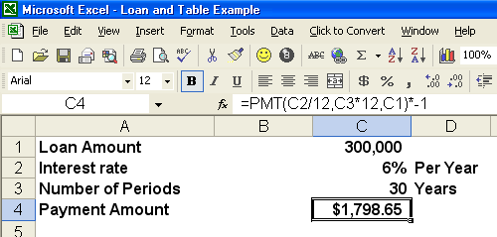

The next step is to create a “Two-Way Data Table” displaying the resulting payment amount given a variety of lengths of the loan. This process is started by creating a list of the alternative loan amounts, as shown below in B8, B9, B10, etc. Cell C7 must reference the results you want to be displayed in the table.

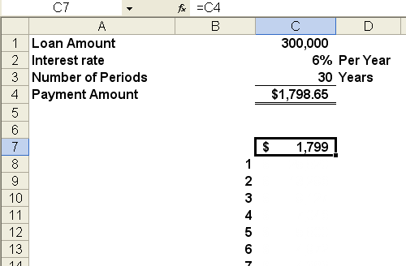

The next step is to highlight the data table range and use the Data Table command under the Data menu (as shown below) to generate the desired table.

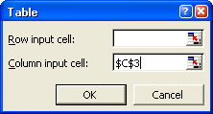

This process will generate the following table:

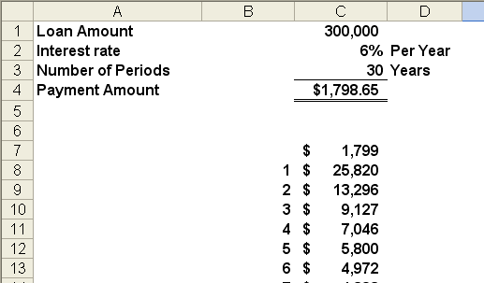

This table tells us that the same loan amount will require a monthly payment of $3,331 to pay the loan off in just 10 years, and a monthly payment of $5,800 to repay the loan in just 5 years.

The next step in this exercise is to generate a line chart based on the data table we just created. This line chart will provide some interesting observations regarding the benefits and detriments of paying off loans over longer periods.

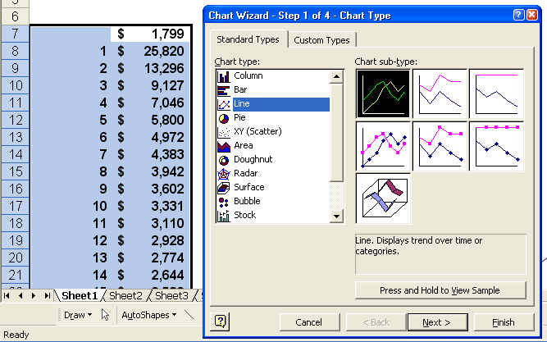

The resulting chart is shown as follows:
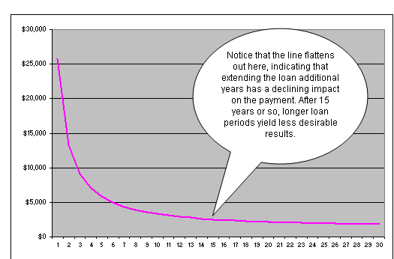

Based on this, no one should ever obtain a fair market loan for more than 15 years, the reduction in payments simply aren’t worth the additional length of the loan. This same basic behavior is seen whether the interest rate is 1% or 100%. The only time you might be justified in obtaining a loan loner than 15 years might be when you are extended a favorable interest – this better than a fair market interest rate.

Goal Seek

If you know the result that you want from a formula, but are not sure what input value the formula needs to get that result, use the Goal Seek feature. For example, suppose that you need to borrow some money. You know how much money you want, how long you want to take to pay off the loan, and how much you can afford to pay each month. You can use Goal Seek to determine what interest rate you will need to secure in order to meet your loan goal. Goal Seek works only with one variable input value. If you want to accept more than one input value; for example, both the loan amount and the monthly payment amount for a loan, you use the Solver add-in discussed at the end of this manual.

Scenarios

Scenario Manager allows you to create and save multiple “what if” scenarios (such as best case, most likely, and worst cases scenarios). You can also create a summary table of the scenario results in seconds. It is particularly useful for worksheets such as budgets in which users have often saved multiple copies of the same worksheet to accomplish the same objective. An example is shown below. In this example, a tire company has prepared a revenue budget for the coming year, and has created three alternative scenarios to generate the revenues that will result given a variety of mark up assumptions – in this case 100%, 110% and 120% markups.

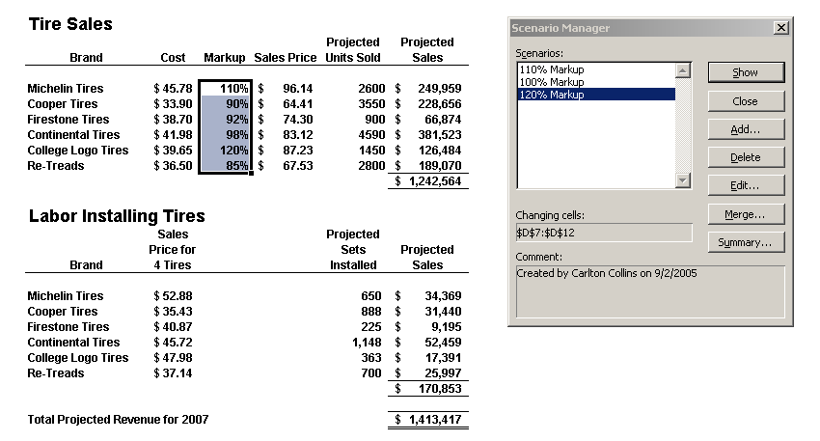

Pressing the summary button in the scenario manager dialog box will create the following Pivot Table of possible alternative results. Here we see detailed revenue projections for all tires and labor fees given all three possible scenarios of 100%, 110%, and 120% markup.

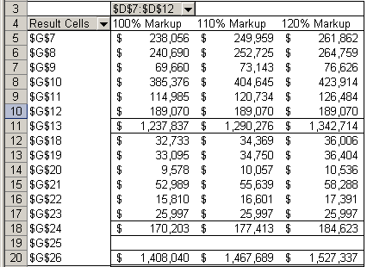

With a few simple copy paste commands, the newly created data can be positioned and formatted next to the original projections as shown in the screen below.

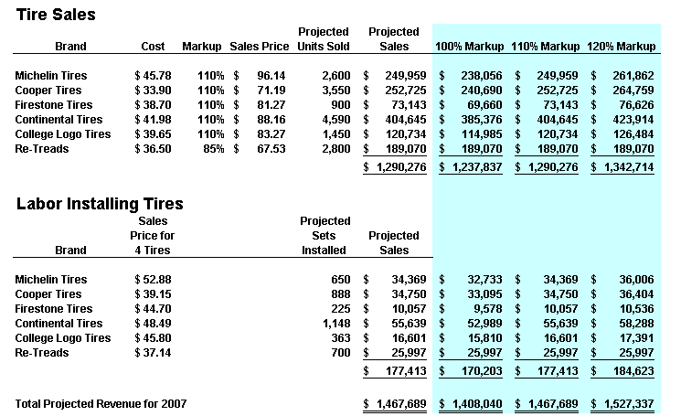

Of course the scenarios above could have been created easily using simple formulas instead of using the scenario manager tool as described above. This underscores that best purpose of scenario manager which is to keep track of older and changing data through time, rather than producing what-if scenarios. For example, a complex projection containing scenarios based on original assumptions, revised assumptions, and final assumptions will allow management to go back and review the assumptions used throughout the project, and see how those assumptions changed as project planning progressed.
Data - Text to Columns

As discussed earlier in this manual, often CPAs receive data from their clients or IT departments that is in text form. When this happens, Excel can split the contents of one or more cells in a column and distribute those contents as individual parts across other cells in adjacent columns. For example, the worksheet below contains a column of full names and amounts that you want to split into separate columns. The Text to Columns Wizard parses the data automatically into separate

Select the cell, range (range: Two or more cells on a sheet. The cells in a range can be adjacent or nonadjacent.), or entire column that contains the text values that you want to split. Note A range that you want to split can include any number of rows, but it can include no more than one column. You also should keep enough blank columns to the right of the selected column to prevent existing data in adjacent

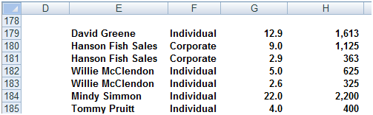
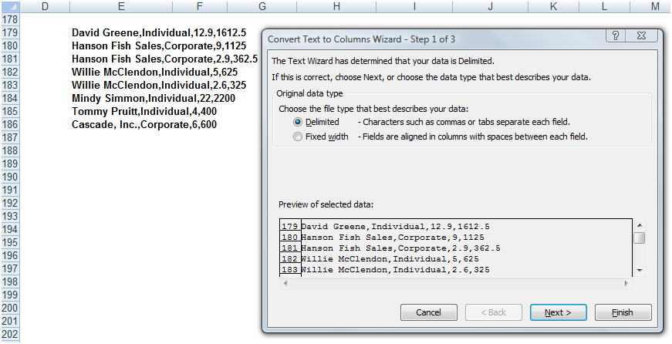

Data Consolidate

Excel can combine, summarize, and report consolidated results from separate worksheets. The underlying worksheets can be in the same workbook or in other separate workbooks. There are two different sitautions as follows:

- You Are Consolidating Similar Data – Such as departmental budgets where every worksheet contains the exact same labels in the exact same cells. In this case, you can write a “Spearing Formula” which can consolidate the necessary information easily.

- You Are Consolidating Dis-Similar Data – The various worksheets contain different row and column descriptions located in different locations on the worksheets. In this case you should use the Data Consolidate command.
For example, assume that you have received budgets from multiple departments, and you want to combine them together. In this case, Excel will do the work for you. You can use a consolidation to roll up these figures into a corporate budget worksheet, as shown below.

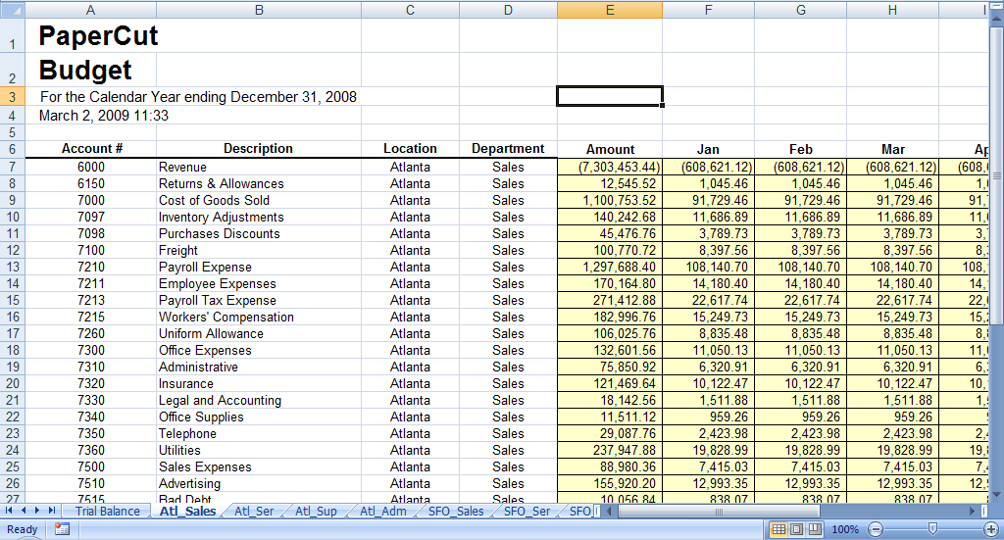

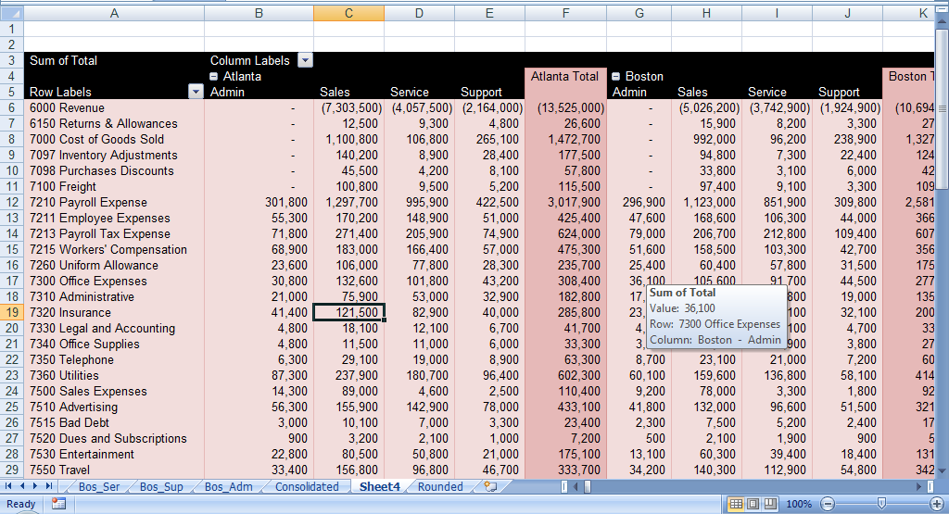
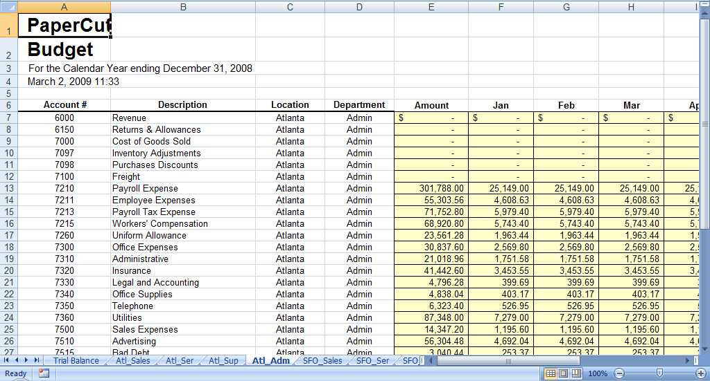
Data Grouping & Outlining

If you have a list of data that you want to group and summarize, you can create an outline of up to eight levels, one for each group. Each inner level, represented by a higher number in the outline symbols displays detail data for the preceding outer level, represented by a lower number in the outline symbols. Use an outline to quickly display summary rows or columns, or to reveal the detail data for each group. You can create an outline of rows (as shown in the example below), an outline of columns, or an outline of both rows and columns.

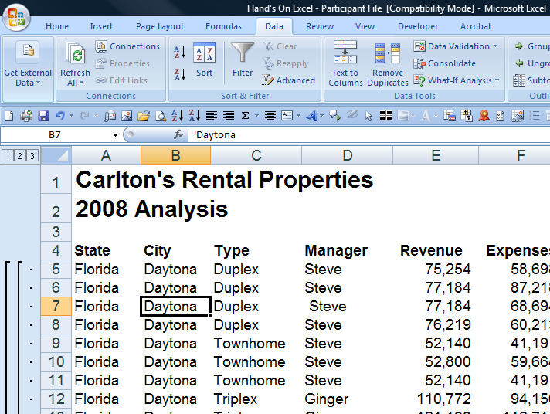

Web Queries

Excel includes pre-designed “queries” that can import commonly used data in 10 seconds. For example, you could use a web query to create a stock portfolio. All you need is a connection to the Internet and of course, some stock ticker symbols. In Excel 2003 select “Data, Import External Data, Import Data” and walk through the web query wizard for importing stock quotes. In Excel 2007 and later use the Data Ribbon, Existing Connections, Stock Quotes option. In seconds, Excel will retrieve 20 minute delayed stock prices from the web (during the hours when the stock market is open) and display a grid of complete up-to-date stick price information that is synchronized to the stock market’s changing stock prices. With each click of the “Refresh” button, the stock price information in Excel is updated - this sure beats picking numbers out of the newspaper.

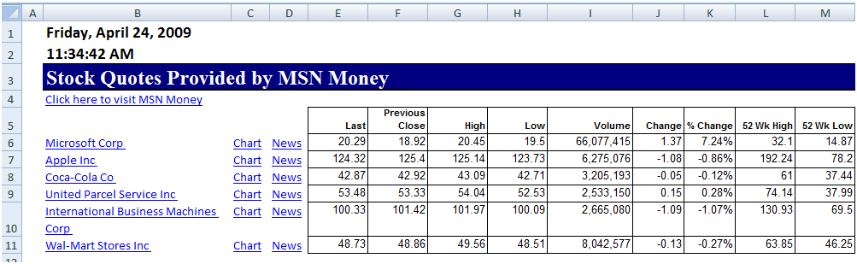

Completing the Stock Portfolio – Next link the grid data to another worksheet, and insert new columns containing the number of shares owned, as wells as an additional column to computer the total value based on shares owned, as shown below.

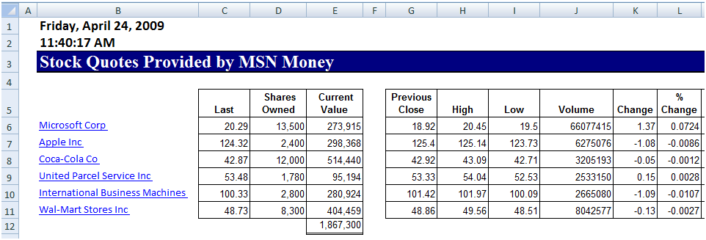

Refreshing the Stock Prices - Once you have created your portfolio, simply click the Refresh Data button on the “External Data” Toolbar in Excel 2003 or on the “Data Ribbon” in Excel 2007 shown below to update the current value of your Portfolio.

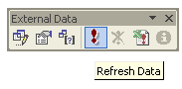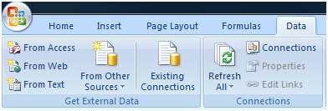

Query Parameters - There are numerous options to help you extract exactly the data you want they way you want it. The “Web Query Parameters Box”, “Web Query Options box” and “External Data Properties Box” provide numerous options for controlling your web query.

Database Queries

Microsoft Excel can also query and retrieve data you want from an external data source. For example, you can retrieve Microsoft Excel data about a specific product by region. You can create a simple query by using the Query Wizard, or you can create a more complex query by using the advanced features of Microsoft Query.

To use Microsoft Query to retrieve external data, you must:

- Have access to an external data source - If the data is not on your local computer, you may need to see the administrator of the external database for a password, user permission, or other information about how to connect to the database.

- Install Microsoft Query - If Microsoft Query is not available, you might need to install it.

- Specify a source to retrieve data from, and then start using Microsoft Query - For example, if you want to insert database information, display the Database toolbar, click Insert Database, click Get Data, and then click MS Query.

For example, suppose we have some data in our accounting system – Sage MAS 200 ERP that we would like to analyze in Excel. We can use the Database Query Wizard to build a query that will extract the data we need and place it in an Excel spreadsheet.

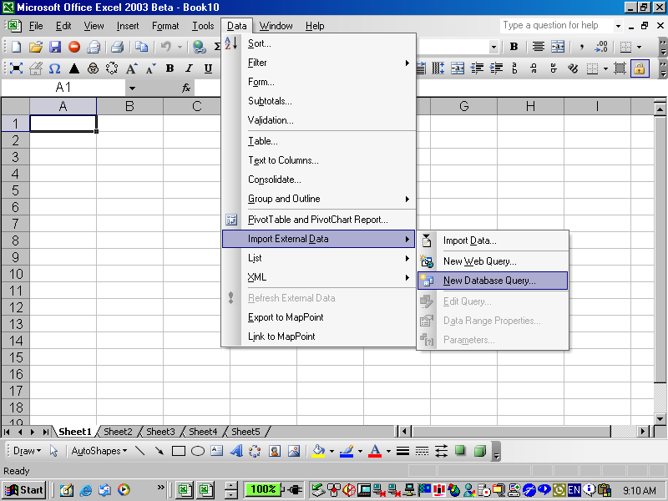
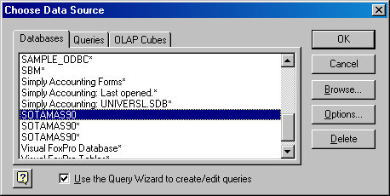

The first step is to select the type of database you want to query and to select the specific database.

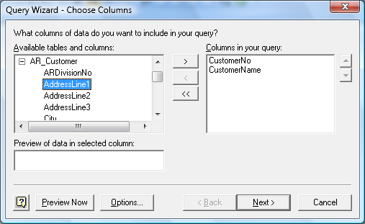

Upon the selection of the desired database a list of tables will be presented. Choose the desired tables, and select the desired data fields to be imported. You will then have the option to filter and sort the data before it is imported. Finally you will be given the option to save the query so that you can run it at a later date without having to start from scratch. Excel will then return a table full of the data you requested as shown in the screen below.

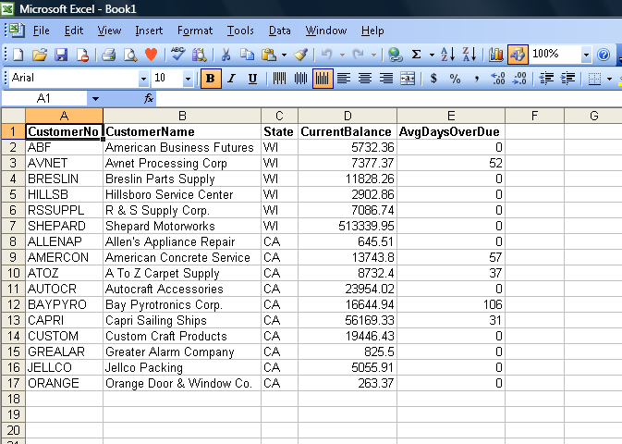

Chapter 5
MACROS
Automating Your Key Strokes

Macros

Macros offer a powerful and flexible way to extend the features of Excel. They allow the automation of repetitive tasks such as printing, formatting, configuring, or otherwise manipulating data in Excel. In its’ simplest form, a macro is a recording of your keystrokes. While macros represent one of the stronger features found in Excel, they are rather easy to create and use. There are six major points that I like to make about macros as follows.

1. Record, Use Excel, Stop Recording – To create a macro, simply turn on the macro recorder, use Excel as you normally do, then turn off the recorder. Presto – you have created a macro. While the process is simple from the user’s point of view, underneath the covers Excel creates a Visual Basic subroutine using sophisticated Visual Basic programming commands.

2. Macro Location – Macros can be stored in either of two locations, as follows:

a. The workbook you are using, or
b. Your Personal Macro Workbook (which by default is hidden from view)

If your macro applies to all workbooks, then store it in the Personal Macro Workbook so it will always be available in all of your Excel workbooks; otherwise store it in your current workbook. A macro stored in your current workbook will be embedded and included in the workbook, even if you e-mail the workbook to another user.

3. Assign your Macro to an Icon, Text or a Button – To make it easy to run your macro, you should assign it to a toolbar icon so it will always be available no matter which workbooks you have open. If the macro applies only to your current workbook, then assign it to Text or a macro Button so it will be quickly available in your current workbook.

4. Absolute versus Relative Macros – An “Absolute” macro will always affect the same cells each time whereas a “Relative” macro will affect those cells relative to where your cursor is positioned when you invoke the macro. It is crucial that you understand the difference.

5. Editing Macros – Once created, you can view and/or edit your macro using the View Macros option. This will open the macro subroutine in a Visual basic programming window and provide you with a plethora of VB tools.

6. Advanced Visual Basic Programming – For the truly ambitious CPA, in the Visual Basic Programming window, you have the necessary tools you need to build very sophisticated macros with dialog boxes, drop down menu options, check boxes, radio buttons – the whole works. I invite you to knock yourself out. To see all of this power, turn on the “Developer Tab” in “Excel Options” (see below).

Presented below are more detailed comments and step-by-step instructions for creating and invoking macros, followed by some example macros.

1. Creating a Macro - To create a macro, click “Record Macro” in the “Code Group” on the Developer Tab.

  - Assign a Name - In the “Macro Name” box, enter a name for the macro.

i. The first character of the macro name must be a letter.
ii. Subsequent characters can be letters, numbers, or underscore characters.
iii. Spaces cannot be used in a macro name (an underscore character is often used as a word separator.
iv. If you use a macro name that is also a cell reference, you may get an error message that the macro name is not valid.

  - Assign a CTRL Combination (optional) – You can assign a CTRL combination shortcut key to run the macro by typing any lowercase letter or uppercase letter that you want to use in the Shortcut key box.

i. The shortcut key will override any equivalent default Excel shortcut key while the workbook that contains the macro is open.

  - Macro Location - In the “Store Macro In” list, select the workbook where you want to store the macro.

i. As mentioned above, if you want a macro to be available whenever you use Excel, select “Personal Macro Workbook”. When you select Personal Macro Workbook, Excel creates a hidden personal macro workbook (Personal.xlsb) if it does not already exist, and saves the macro in this workbook.
ii. In Windows Vista, this workbook is saved in the C:\Users\user name\AppData\Local\Microsoft\Excel\XLStart folder.
iii. In Microsoft Windows XP, this workbook is saved in the C:\Documents and Settings\user name\Application Data\Microsoft\Excel\XLStart folder.
iv. Workbooks in the XLStart folder are opened automatically whenever Excel starts.
v. If you want a macro in the personal macro workbook to be run automatically in another workbook, you must also save that workbook in the XLStart folder so that both workbooks are opened when Excel starts.

  - Macro Description - In the Description box, type a description of the macro.

  - Start Recording - Click OK to start recording.

  - Start Typing - Perform the actions that you want to record.

g. Stop Recording – When you are done click “Stop Recording” in the “Code Group” On the “Developer Tab”.

i. You can also click Stop Recording on the left side of the status bar.

h. Assign a macro to an object, graphic, or control - On a worksheet, right-click the object, graphic, or control to which you want to assign an existing macro, and then click Assign Macro. In the Macro name box, click the macro that you want to assign.

2. Menu Navigation Not Recorded - When you record a macro, the macro recorder records all the steps required to complete the actions that you want your macro to perform. Navigation on the Ribbon is not included in the recorded steps, only the commands that are executed are recorded in the macro.

3. Turn On The Developer Tab - Turn on the Developer tab by clicking the Microsoft Office Start Button, and then click Excel Options. In the Popular category, under Top options for working with Excel, select the Show Developer tab in the Ribbon check box, and then click OK.

4. Enable Macros – If the macro functions are disabled, you can enable them by selecting Macro Security in the Code group on the Developer tab as shown below.

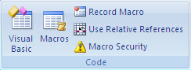

Under Macro Settings, click Enable all macros (not recommended, potentially dangerous code can run), and then click OK.

5. Example Macros

a. Page Setup Macro – Start recording a new macro called page setup. Select all of the worksheets and then choose Page Setup and customize the header and footers to include page numbers, date and time stamps, file locations, tab names, etc. Assign the macro to an Icon on your toolbar or Quick Access Bar and insetting headers and footers will be a breeze for the rest of your life.

b. Print Macros – Do you have a template that you print frequently from? If so, insert several macro buttons to print each report, a group of reports, and even multiple reports and reporting will be snap in the future.

c. Delete Data Macro – Do you have a template that you use often that contains a lot of variables? If so, create a macro that visits each cell and erases that data, resetting the worksheet for use in a new set of criteria. Assign the macro to a macro button and you will never again have old assumptions mixed in with your newer template.

Chapter 6
Miscellaneous

Solver

Solver is one of the more powerful features in Excel because it can solve for optimum results in complex worksheets while obeying stated constraints. With Solver, you can find an optimal value for a formula by manipulating a group of cells that are related, either directly or indirectly, to the formula in the target cell. Solver adjusts the values in the adjustable cells to produce the result you specify from the target cell formula. You can apply constraints to restrict the values Solver can use in the model, and the constraints can refer to other cells that affect the target cell formula.

In the portfolio example shown below, the user wishes to determine how much money to invest in various investments in order to maximize the return on those investments. Of course the maximum results can be achieved by simply place in all monies in the investment that yields the highest results, however this approach violates the “don’t put all of your eggs in one basket rule”. In this case the user wants to diversify their funds across many types of investments. Therefore constraints are established such as no more than 35% of funds can be invested in blue chip stocks and the checking accounting must contain at least $100,000.

A portfolio is shown below and some constraints have been included in lust form. These constraints will need to be stated in terms of formulas in the solver manager dialog box.

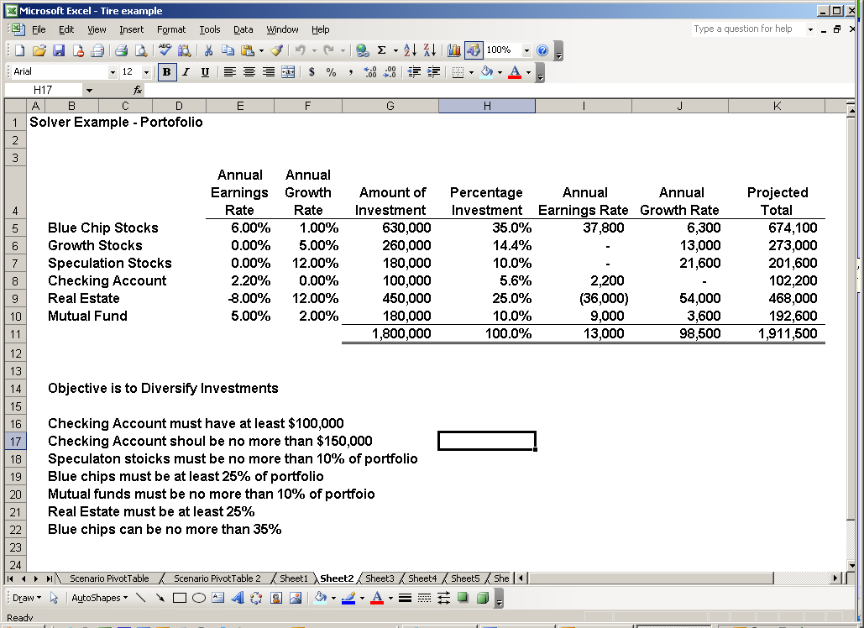

The key to making solver work is the solver Parameters dialog box shown below.

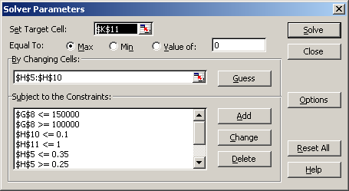

The target cell is set to refer to the total portfolio value at the end of the year because this is the value that we want to maximize. The changing cells are set to reference the percentages of each investment. Finally the various constraints are expressed as formulas as shown in the lower left hand corner of the dialog box. Once solver has been run once, the solver formulas stick to the worksheet and the results are changed and updated as the various assumptions in the worksheet are changed and updated. For example, you may later determine that the growth rate for real estate is a different amount. Inputting that new amount in the worksheet will cause Excel to automatically adjust all variables to produce the optimum investment mix that maximizes earnings without violating any stated constraints.

Chapter 7

XML Data

Overview of XML in ExcelHide All
Microsoft Office Excel makes it easy to import Extensible Markup Language (XML) (Extensible Markup Language (XML): A condensed form of Standard Generalized Markup Language (SGML) that enables developers to create customized tags that offer flexibility in organizing and presenting information.) data that is created from other databases and applications, to map XML elements from an XML schema (XML Schema: A formal specification, written in XML, that defines the structure of an XML document, including element names and rich data types, which elements can appear in combination, and which attributes are available for each element.) to worksheet cells, and to export revised XML data for interaction with other databases and applications. Think of these XML features as turning Office Excel into an XML data file generator with a familiar user interface.

- Why use XML in Excel?

  - XML data and schema files
  - Key XML and Excel scenarios
- The basic process of using XML data in Excel
  - Working with XML maps
  - Using the XML Source task pane
  - Element types and their icons
  - Working with single-mapped cells
  - Working with repeating cells in XML tables
  - XML map security considerations
  - Importing XML data
  - Working with an inferred schema
  - Exporting XML data
- Using the Excel macro-enabled Office XML Format file

Why use XML in Excel?
XML is a technology that is designed for managing and sharing structured data in a human-readable text file. XML follows industry-standard guidelines and can be processed by a variety of databases and applications. Using XML, application designers can create their own customized tags, data structures, and schemas. In short, XML greatly eases the definition, transmission, validation, and interpretation of data between databases, applications, and organizations.

XML data and schema files
Excel works primarily with two types of XML files:
- XML data files (.xml), which contain the custom tags and structured data.
- Schema files (.xsd), which contain schema tags that enforce rules, such as data type and validation.
Note The XML standard also defines Extensible Stylesheet Language Transformation (XSLT) (XSL Transformation (XSLT): A file that is used to transform XML documents into other types of documents, such as HTML or XML. It is designed for use as part of XSL.) (.xslt) files, which are used to apply styles and transform XML data into different presentation formats. You can apply these transforms before you import XML files into Excel and after you export XML files from Excel. If XSLT files are linked to XML data files that you import into Excel, you do have the option to apply or not apply the formatting before the data is added to the worksheet, but only when you open an XML file by using the Open command on the Microsoft Office Button .

Key XML and Excel scenarios
By using XML and Excel, you can manage workbooks and data in ways that were previously impossible or very difficult. By using XML maps, you can easily add, identify, and extract specific pieces of business data from Excel documents. For example, an invoice that contains the name and address of a customer or a report that contains last quarter's financial results are no longer just static reports. You can easily import this information from databases and applications, revise it, and export it to the same or other databases and applications. The following are key scenarios that the XML features are designed to address:

- Extend the functionality of existing Excel templates by mapping XML elements onto existing cells. This makes it easier to get XML data into and out of your templates without having to redesign them.
- Use XML data as input to your existing calculation models by mapping XML elements onto existing worksheets.
- Import XML data files into a new workbook.
- Import XML data from a Web service into your Excel worksheet.
- Export data in mapped cells to XML data files independent from other data in the workbook.

The basic process of using XML data in Excel
The following diagram shows how the different files and operations work together when you use XML with Excel. Essentially, there are five phases to the process:

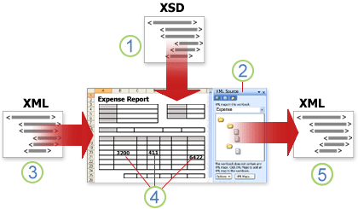
- Adding an XML schema file (.xsd) to a workbook
- Mapping XML schema elements to individual cells or XML tables
- Importing an XML data file (.xml) and binding the XML elements to mapped cells
- Entering data, moving mapped cells, and leveraging Excel functionality, while preserving XML structure and definitions
- Exporting revised data from mapped cells to an XML data file

Working with XML maps
You can create or open a workbook in Excel, attach an XML schema file (.xsd) to the workbook, and then use the XML Source task pane to map XML elements of the schema to individual cells or tables. After you map the XML elements to your worksheet, you can import and export XML data into and out of the mapped cells. When you add an XML schema file (.xsd) to your workbook, you create an XML map. In general, XML maps are used to create mapped cells and to manage the relationship between mapped cells and individual elements in the XML schema. In addition, these XML maps are used to bind the contents of mapped cells to elements in the schema when you import or export XML data files (.xml).
There are two kinds of mapped cells that you can create: single-mapped cells and repeating cells (which appear as XML tables). To make designing your worksheet more flexible, you can drag the mapped cells anywhere on a worksheet and into any order — even one different from the XML schema. You can also choose which elements to map and not map.

The following rules about using XML maps are important to know:
- A workbook can contain one or more XML maps.
- You can only map one element to one location in a workbook at a time.
- Each XML map is an independent entity, even if multiple XML maps in the same workbook refer to the same schema.
- An XML map can only contain one root element. If you add a schema that defines more than one root element, you are prompted to choose the root element to use for the new XML map.

Using the XML Source task pane
You use the XML Source task pane to manage XML maps. To open it, on the Developer tab, in the XML group, click Source. The following diagram shows the main features of this task pane.

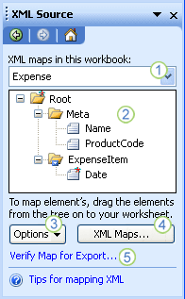

- Lists XML maps that were added to the workbook
- Displays a hierarchical list of XML elements in the currently listed XML map
- Sets options when working with the XML Source task pane and the XML data, such as how to preview the data and control headings
- Opens the XML Maps dialog box, which you can use to add, delete, or rename XML maps
- Verifies whether you can export XML data through the current XML map

Element types and their icons
The following table summarizes each type of XML element that Excel can work with and the icon that is used to represent each type of element.

Element type | Icon
Parent element
Required parent element
Repeating parent element
Required repeating parent element
Child element
Required child element
Repeating child element
Required repeating child element
Attribute
Required attribute
Simple content in a complex structure
Required simple content in a complex structure

Working with single-mapped cells
A single-mapped cell is a cell that has been mapped to a nonrepeating XML element. You create a single-mapped cell by dragging a nonrepeating XML element from the XML Source task pane onto a single cell in your worksheet. When you drag a nonrepeating XML element onto the worksheet, you can use a smart tag to choose to include the XML element name as a heading above or just to the left of the single-mapped cell, or you can use an existing cell value as a heading. You can also use a formula in a single-mapped cell, if the cell is mapped to an XML element with an XML Schema Definition (XSD) data type that Excel interprets as a number, date, or time.

Working with repeating cells in XML tables
XML tables are similar in appearance and functionality to Excel tables. An XML table is an Excel table that has been mapped to one or more XML repeating elements. Each column in the XML table represents an XML element. An XML table is created when you:

- Use the Import command (in the XML group on the Developer tab) to import an XML data file.
- Use the Open command (on the Microsoft Office Button ) to open an XML data file — and then select As an XML table in the Open XML dialog box.
- Use the From XML Data Import command (from the From Other Sources command button, in the Get External Data group, on the Data tab) to import an XML data file — and then select XML table in existing worksheet or New worksheet in the Import Data dialog box.
- Drag one or more repeating elements from the XML Source task pane to a worksheet.
- When you create an XML table, the XML element names are automatically used as column headings. You can change these to any column headings that you want. However, the original XML element names are always used when you export data from the mapped cells.

Two options under the Options button in the XML Source task pane are useful when you work with XML tables:
- Automatically Merge Elements When Mapping When selected, Excel creates one XML table from multiple fields as they are dropped onto the worksheet. This option works as long as the multiple fields are dropped on the same row, one adjacent to the other. When this option is cleared, each element appears as its own XML table.
- My Data Has Headings When selected, existing heading data is used as column headings for repeating elements that you map to your worksheet. When this option is cleared, the XML element names are used as column headings.

Using XML tables, you can easily import, export, sort, filter, and print data based on an XML data source. However, XML tables do have some limitations regarding how they can be arranged on the worksheet.
- XML tables are row-based, meaning that they grow from the header row down. You cannot add new entries above existing rows. You cannot transpose an XML table so that new entries will be added to the right. You can use formulas in columns that are mapped to XML elements with an XML Schema Definition (XSD) data type that Excel interprets as a number, date, or time. Just as in an Excel table, formulas in an XML table are filled down the column when new rows are added to the table.

XML map security considerations
An XML map and its data source information are saved with the Excel workbook, not a specific worksheet. A malicious user can view this map information by using a Microsoft Visual Basic for Applications (VBA) macro. Furthermore, if you save your workbook as a macro-enabled Excel Open XML Format File, this map information can be viewed through Microsoft Notepad or through another text-editing program.

If you want to keep using the map information but remove the potentially sensitive data source information, you can delete the data source definition of the XML schema from the workbook, but still export the XML data, by clearing the Save data source definition in workbook check box in the XML Map Properties dialog box, which is available from the Map Properties command in the XML group on the Developer tab.

If you delete a worksheet before you delete a map, the map information about the data sources, and possibly other sensitive information, is still saved in the workbook. If you are updating the workbook to remove sensitive information, make sure that you delete the XML map before you delete the worksheet, so that the map information is permanently removed from the workbook.

Importing XML data
You can import XML data into an existing XML map in your workbook. When you import data, you bind the data from the file to an XML map that is stored in your workbook. This means that each data element in the XML data file has a corresponding element, in the XML schema, that you mapped from an XML Schema file or inferred schema. Each XML map can only have one XML data binding, and an XML data binding is bound to all of the mappings that were created from a single XML map. You can display the XML Map Properties dialog box (Click Map Properties in the XML group on the Developer tab.), which has three options, all selected by default, that you can set or clear to control the behavior of an XML data binding:

- Validate data against schema for import and export Specifies whether Excel validates data against the XML map when importing data. Click this option when you want to ensure that the XML data that you import conforms to the XML schema.
- Overwrite existing data with new data Specifies whether data is overwritten when you import data. Click this option when you want to replace the current data with new data, for example, when up-to-date data is contained in the new XML data file.
- Append new data to existing XML tables Specifies whether the contents of the data source are appended to the existing data on the worksheet. Click this option, for example, when you are consolidating data from several similar XML data files into an XML table, or you do not want to overwrite the contents of a cell that contains a function.

When you import XML data, you may want to overwrite some mapped cells but not others. For example, some mapped cells may contain formulas and you don't want to overwrite the formula when you import an XML file. There are two approaches that you can take:

- Unmap the elements that you don't want overwritten, before you import the XML data. After you import the XML data, you can remap the XML element to the cells containing the formulas, so that you can export the results of the formulas to the XML data file.
- Create two XML maps from the same XML schema. Use one XML map for importing the XML data. In this "Import" XML map, don't map elements to the cells that contain formulas or other data that you don't want overwritten. Use another XML map for exporting the data. In this "Export" XML map, map the elements that you want to export to an XML file.

The ability to import XML data from a Web service by using a Data Retrieval Service Connection (.uxdc) file to connect to a data source is no longer supported in Microsoft Office Excel 2007 through the user interface. If you open a workbook that was created in Office Excel 2003, you can still view the data, but you cannot edit or refresh the source data.

Working with an inferred schema
If you import XML data without first adding a corresponding XML schema to create an XML map, Excel tries to infer a schema for you based on the tags that are defined in the XML data file. The inferred schema is stored with the workbook, and the inferred schema allows you to work with XML data if an XML schema file isn't associated with the workbook. When you work with imported XML data that has an inferred schema, you can also customize the XML Source task pane. Select the Preview Data in Task Pane option from the Options button to display the first row of data as sample data in the element list, if you imported XML data associated with the XML map in the current session of Excel.
You cannot export the Excel inferred schema as a separate XML schema data file (.xsd). Although there are XML schema editors and other methods for creating an XML schema file, you may not have convenient access to them or know how to use them. As an alternative, you can use the Excel 2003 XML Tools Add-in Version 1.1, which can create a schema file from an XML map. For more information, see Using the Excel 2003 XML Tools Add-in Version 1.1.

Exporting XML data
You export XML data by exporting the contents of mapped cells on the worksheet. When you export data, Excel applies the following rules to determine what data to save and how to save it:

- Empty items are not created when blank cells exist for an optional element, but empty items are created when blank cells exist for a required element.
- Unicode Transformation Format-8 (UTF-8) encoding is used to write the data.
- All namespaces are defined in the Root XML element.
- Excel overwrites existing namespace prefixes. The default namespace is assigned a prefix of ns0. Successive namespaces are designated ns1, ns2 to ns<count> where <count> is the number of namespaces written to the XML file.
- Comment nodes are not preserved.
- You can display the XML Map Properties dialog box (Click Map Properties in the XML group on the Developer tab.) and then use the Validate data against schema for import and export option (active by default) to specify whether Excel validates data against the XML map when exporting data. Click this option when you want to ensure that the XML data you export conforms to the XML schema.

Using the Excel Macro-enabled Office XML Format File
You can save an Excel workbook in a variety of file formats, including the Excel macro-enabled Office XML Format File (.xlsm). Excel has a defined XML schema that defines the contents of an Excel workbook, including XML tags that store all workbook information, such as data and properties, and define the overall structure of the workbook. Custom applications can use this Excel macro-enabled Office XML Format File. For example, developers may want to create a custom application to search for data in multiple workbooks that are saved in the this format and create a reporting system based on the data found.

Chapter 8

Excel Quick Tips

50 Quick Tips

The Excel workbook used in class to demonstrate these quick tips can be downloaded instantly at the following address: www.ExcelAdvisor.net Password: 2007collins
1 | Right Click Status Bar - (View sums, averages, mins, maxes immediately)
2 | CTRL + Mouse Scroll - (Zoom in & out with your mouse)
3 | Double Click the Format Painter - (Tool sticks until clicked again)
4 | Replace Formatting - (Find and replace one formatting with another)
5 | Click on Edge of Cell - (Navigate in a range of cells)
6 | Turn off Task Pane - (Put an end to TaskPane)
7 | Control Tilde (CTRL + ~) - (View underlying formulas)
8 | Indent Icon - (Indent cells or columns instantly)
9 | ALT + Down Arrow (or Shift-F10) - (Pick from a drop down list)
10 | F4 - (Repeat the last command such as insert rows or change row height)
11 | Alt + Enter - (Wrap text instantly)
12 | & - (Combine text from multiple cells)
13 | Right Click Tab, Copy, Create Copy - (Insert new sheet with headers, footers, etc)
14 | File, Send To, Mail Recipient - (E-Mail a worksheet, workbook or chart)
15 | ComboBox from Forms Toolbar - (Insert a combobox)
16 | Double Click Fill Handle - (Copies formula down the relevant range)
17 | =Upper, =Lower, =Proper - (Change text case)
18 | Paste Special, Values - (Convert formulas to numbers)
19 | F4 in Edit Mode - (Toggle Absolute References)
20 | Paste Special, Transpose - (Invert a matrix of numbers)
21 | Ctrl + D - (Copy Data to the down)
22 | Ctrl + R - (Copy data to the right)
23 | Defined Names - (Refer to names rather than cell addresses)
24 | Data, AutoFilter, Advanced, Copy, Unique - (Extract unique values)
25 | Tools, Options, Calculation, Precision as Displayed (Avoid rounding errors)
26 | Right Click Toolbar, Options, Show Full Menus - (Show all menu options)
27 | Tools, View, Zero Values - (Hide zero values)
28 | Tools, AutoCorrect, Smart Tags, None - (Turn off Smart Tags)
29 | Filter Data, Apply Color, Un-filter Data - (Color filtered results)
30 | PDF2XL - ($95 product converts PDF's to Excel files)
31 | Data Validation - (Insert a pop up comment into a cell)
32 | Ctrl+Shft+End - (Select row to the right)
33 | Ctrl+Shft+Home - (Select row to the left)
34 | F11 - (Produce a quick chart)
35 | Print Area in Name Box - (Quickly identify the print area)
36 | Displaying the Styles Tool - (Toolbar access to styles)
37 | Format, Styles - (Create new styles)
38 | Control Panel, Regional Options - (Control how dates are displayed)
39 | =Substitute - (Remove or replace unwanted characters)
40 | View, Sized with Window - (Resizes chart to fit Window)
41 | Ctrl+Spacebar - (Select a column)
42 | Shift+Spacebar - (Select a row)
43 | Alt+Tab - (Toggle between applications or Excel workbooks)
44 | Delete Blank Rows and Columns, Ctrl+S - (Reduce relevant area and scroll bar)
45 | Copy Formula, to Blank Cells - (Fill in missing data in a list)
46 | =ISTEXT(A1) - (Use this formula in conditional formatting to format text only)
47 | Replace, Within - (Tip for replacing throughout entire workbook)
48 | =LEN(A1)-LEN(SUBSTITUTE(A1,A2,"")) - (Count the occurrence of a character)
49 | =MID(A25,FIND("*",SUBSTITUTE(A25,"\","*",LEN(A25)-LEN(SUBSTITUTE(A25,"\",""))))+1,LEN(A25)) - (Extract the Filename)
50 | =SumIF - (Sum only those numbers that meet specific criteria)

Bonus Tips – 20 Additional Excel Tips:

- =Left
- =Find
- =Mid
- =Right
- =Len
- Transition turned on
- Move on edit turned off
- AutoCorrect
- Rename Tab
- Color Tab
- Reorder Tabs
- Select Multiple Tabs
- Fixed decimal places
- Turn off AutoComplete - Tools, Options, Edit
- Enter Formats automatically
- Show 50 / 9 recently used files
- Default File Format - Tools, Options, Transition
- Embedded Voice clips
- Embedded Video Clips
- Organization Charts

Chapter 9

What’s New in
Excel 2007?

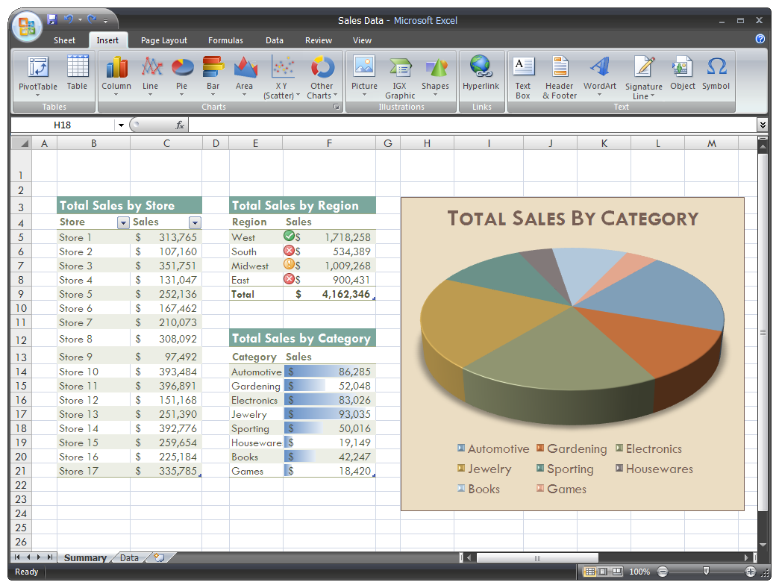

Enhancements to Excel 2007

- More Columns - Increased the total number of available columns in Excel from 256 (2^8) to 16,000 (2^14).

- More Rows - Increased the total number of available rows in Excel from 64,000 (2^16) to 1,000,000 (2^20).

- More Memory - Increased the total amount of PC memory that Excel can use from 1GB to as much RAM as Windows sees.

- Dual Core Chips - Office Excel 2007 supports multiple microcomputer processors and multithreaded chipsets.

- More Colors - Excel 2007 now supports up to 16 million colors, up from 256.

- Sort by Color. Wow!

- More Sorting Criteria - Increased the number of levels of sorting on a range or table from 3 to 64.

- More Characters in a cell - Increased the total number of characters that can display in a cell by 32-fold. More specifically, this limit was increased from 1k (when the text is formatted) to 32k or unlimited (regardless of formatting).

- Find More items - Increased the maximum number of items found by “Find All” from 65,472 to 2 Billion.

- More Pivot Rows - Increased the number of rows allowed in a PivotTable from 64k to 1,000,000 (2^20).

- Arrays Reference More Rows - Eliminated the limit on the number of rows of a column or columns that can be referred to in an array formula.

- More Conditional Formats - Increased the number of conditional format conditions on a cell from 3 conditions to limited by available memory.

- More AutoFilter Results - Increased the number of items shown in the Auto-Filter dropdown from 1,000 to 10,000.

- Print More Characters in a Cell - Increased the number of characters per cell that Excel can print from 1k to 32k.

- More Styles - Increased the total number of unique cell styles in a workbook (combinations of all cell formatting) from 4,000 to 64,000.

- Larger Formulas - Increased the maximum length of formulas (in characters) from 1,000 characters to 8,000 characters.

- More Formula Nesting - Increased the number of levels of nesting that Excel allows in formulas from 7 to 64.

- More Arguments - Increased the maximum number of arguments to a function from 30 to 255.

- More Pivot Columns - Increased the number of columns allowed in a Pivot Table from 255 to 16,000.

- More Unique Pivot Items - Increased maximum number of unique items within a single Pivot Field from 32,000 to 1,000,000.

- More Pivot Fields - Increased the number of fields (as seen in the field list) that a single PivotTable can have from 255 to 16,000.

- Longer Pivot Names - Increased length of the MDX name for a Pivot Table item; also the string length for a relational Pivot Table from 255 characters to 32,000.

- Better Pivot Truncation - Increased the length at which fields’ labels are truncated when added to PivotTable; this also includes caption length limitations from 255 to 32,000.

- Better Partial Calculations - Increased the number of cells that may depend on a single area before Excel must do full calculations instead of partial calculations (because it can no longer track the dependencies required to do partial calculations) from 8,000 to limited by available memory.

- More Array References - Increased the number of array formulas in a worksheet that can refer to another (given) worksheet from 65,000 to limited by available memory.

- Bucket More Functions - Increased the number of categories that custom functions can be bucketed into from 32 to 255.

- Better External Updates - Increased the number of characters that may be updated in a non-resident external workbook reference from 255 to 32,000.

- Themes - Excel allows users to format data by applying a theme using a specific style.

- Share Themes - Themes can be shared across other 2007 Office release programs. You can also customize a theme style.

- Chart Styles – Excel offers predefined chart styles, but you cannot create your own chart styles.

- Quicker Styles - Excel now provides a quicker method to apply a predefined cell style.

- Better Conditional Formatting - Use conditional formatting to visually annotate your data for both analytical and presentation purposes.

- Stronger Conditional Formatting - To easily find exceptions and to spot important trends in your data, you can implement and manage multiple conditional formatting rules that apply rich visual formatting in the form of gradient colors, data bars, and icon sets to data that meets those rules. Conditional formats are also easy to apply—in just a few clicks, you can see relationships in your data that you can use for your analysis purposes.

- Resizable formula bar - The formula bar automatically resizes to accommodate long, complex formulas, which prevents the formulas from covering other data in your worksheet.

- Function AutoComplete - Function AutoComplete helps users write formulas using the proper formula syntax.

- Structured References - In addition to cell references, such as A1 and R1C1, Excel now provides structured references to named ranges and tables in a formula.

- Easier Access to Named Ranges - Excel name manager organizes, updates, and manages multiple named ranges in a central location, which helps anyone who needs to work on your worksheet interpret its formulas and data.

- New OLAP - When you work with multidimensional databases (such as SQL Server Analysis Services) Excel can use OLAP formulas to build complex, free form, OLAP data bound reports. New cube functions are used to extract OLAP data (sets and values) from Analysis Services and display it in a cell. OLAP formulas can be generated when you convert PivotTable formulas to cell formulas or when you use AutoComplete for cube function arguments when you type formulas.

- Enhanced Filtering - Filter data by color or by dates, display more than 1000 items in the AutoFilter drop-down list, select multiple items to filter, and filter data in PivotTables.

- Table Enhancements - New or improved functionality for tables includes the following features:

  - Table Header Rows - Table header rows can be turned on or off. When table headers are displayed, they stay visible with the data in the table columns by replacing the worksheet headers when you move around in a long table.

  - Calculated Columns - A calculated column uses a single formula that adjusts for each row. It automatically expands to include additional rows so that the formula is immediately extended to those rows. All that you have to do is enter a formula once—you don't need to use the Fill or Copy commands.

  - Automatic Autofiltering - AutoFilter is turned on by default in a table to enable powerful sorting and filtering of table data.

  - Structured References - This type of reference allows you to use table column header names in formulas instead of cell references, such as A1 or R1C1.

  - Total Rows - In a total row, you can now use custom formulas and text entries.

  - Table Styles - You can apply a table style to quickly add designer-quality, professional formatting to tables. If an alternate-row style is enabled on a table, Excel will maintain the alternating style rule through actions that would have traditionally disrupted this layout, such as filtering, hiding rows, or manual rearranging of rows and columns.

- Presentation Quality Charts - New charting tools to create professional-looking charts. The new, up-to-date look for charts includes special effects, such as 3-D, transparency, and soft shadows.

- Chart Themes – Charts follow the theme that is applied to your workbook.

- Visual Chart Element Pickers - Quickly change every element of the chart to best present your data. For example, in a few clicks, you can add or remove titles, legends, data labels, trendlines, and other chart elements.

- A Modern look with OfficeArt - Because charts in Excel are now drawn with OfficeArt, almost anything you can do to an OfficeArt shape can also be done to a chart and its elements. For example, you can add a soft shadow or bevel effect to make an element stand out or use transparency to make elements visible that are partially obscured in a chart layout. You can also use realistic 3-D effects.

- Clear Lines and Fonts - Lines in charts appear less jagged, and ClearType fonts are used for text to improve readability.

- Chart Templates - Save your favorite charts as a chart template.

- Using Excel Charts in Other Programs - Charts shared between Excel, Word, and PowerPoint now incorporate the powerful charting features of Excel, including the use of formulas, filtering, sorting, and the ability to link a chart to external data sources, such as Microsoft SQL Server and Analysis Services (OLAP), for up-to-date information in your chart.

- Copying charts to other programs Charts can be easily copied and pasted between documents or from one program to another. When you copy a chart from Excel to Word or PowerPoint, it automatically changes to match the Word document or PowerPoint presentation, but you can also retain the Excel chart format. The Excel worksheet data can be embedded in the Word document or PowerPoint presentation, but you can also leave it in the Excel source file.

- Animating charts in PowerPoint In PowerPoint, you can more easily use animation to emphasize data in an Excel-based chart. You can animate the entire chart or the legend entry and axis labels. In a column chart, you can even animate individual columns to better illustrate a specific point. Animation features are easier to find and you have a lot more control. For example, you can make changes to individual animation steps, and use more animation effects.

- New PivotTable Controls - New PivotTable controls provide better drag and drop zone targets.

- New PivotTable Features - New or improved features are provided to summarize, analyze, and format PivotTable data.

- Using Undo in PivotTables - You can now undo most actions that you take to create or rearrange a PivotTable.

- Plus and Minus Drill-Down Indicators - These indicators are used to indicate whether you can expand or collapse parts of the PivotTable to see more or less information.

- Sorting and filtering Sorting is now as simple as selecting an item in the column that you want to sort and using sort buttons. You can filter data by using PivotTable filters, such as date filters, label filters, value filters, or manual filters.

- Conditional formatting You can apply conditional formatting to an Office Excel 2007 Pivot Table by cell or by intersection of cells.

- PivotTable style and layout Just like you can for Excel tables and charts, you can quickly apply a predefined or custom style to a PivotTable. And changing the layout of a PivotTable is also much easier to do in the new user interface.

- PivotCharts Like PivotTables, PivotCharts are much easier to create in the new user interface. All of the filtering improvements are also available for PivotCharts. When you create a PivotChart, specific PivotChart tools and context menus are available so that you can analyze the data in the chart. You can also change the layout, style, and format of the chart or its elements the same way that you can for a regular chart. In Office Excel 2007, the chart formatting that you apply is preserved when you make changes to the PivotChart, which is an improvement over the way it worked in earlier versions of Excel.

- Quick Connections To External Data In Office Excel 2007, you no longer need to know the server or database names of corporate data sources. Instead, you can use Quick Launch to select from a list of data sources that your administrator or workgroup expert has made available for you. A connection manager in Excel allows you to view all connections in a workbook and makes it easier to reuse a connection or to substitute a connection with another one.

- New File Formats Xml-Based File Format In 2007 Microsoft Office system, Microsoft is introducing new file formats for Word, Excel, and PowerPoint, known as the Office Open XML formats. These new file formats facilitate integration with external data sources, and also offer reduced file sizes and improved data recovery. In Office Excel 2007, the default format for an Excel workbook is the Office Excel 2007 XML-based file format (.xlsx). Other available XML-based formats are the Office Excel 2007 XML-based and macro-enabled file format (.xlsm), the Office Excel 2007 file format for an Excel template (.xltx), and the Office Excel 2007 macro-enabled file format for an Excel template (.xltm).

- Office Excel 2007 binary file format In addition to the new XML-based file formats, Office Excel 2007 also introduces a binary version of the segmented compressed file format for large or complex workbooks. This file format, the Office Excel 2007 Binary (or BIFF12) file format (.xls), can be used for optimal performance and backward compatibility.

- Compatibility with earlier versions of Excel You can check an Office Excel 2007 workbook to see if it contains features or formatting that are not compatible with an earlier version of Excel so that you can make the necessary changes for better backward compatibility. In earlier versions of Excel, you can install updates and converters that help you open an Office Excel 2007 workbook so that you can edit it, save it, and open it again in Office Excel 2007 without losing any Office Excel 2007-specific functionality or features.

- Page Layout View The Normal view and Page Break Preview view, Office Excel 2007 provides a Page Layout View. You can use this view to create a worksheet while keeping an eye on how it will look in printed format. In this view, you can work with page headers, footers, and margin settings right in the worksheet, and place objects, such as charts or shapes, exactly where you want them. You also have easy access to all page setup options on the Page Layout tab in the new user interface so that you can quickly specify options, such as page orientation. It's easy to see what will be printed on every page, which will help you avoid multiple printing attempts and truncated data in printouts.

- Saving to PDF and XPS format You can save as a PDF or XPS file from a 2007 Microsoft Office system program only after you install an add-in.

- Using Excel Services to share your work If you have access to Excel Services, you can use it to share your Office Excel 2007 worksheet data with other people, such as executives and other stakeholders in your organization. In Office Excel 2007, you can save a workbook to Excel Services and specify the worksheet data that you want other people to see. In a browser, they can then use Microsoft Office Excel Web Access to view, analyze, print, and extract this worksheet data. They can also create a static snapshot of the data at regular intervals or on demand. Office Excel Web Access makes it easy to perform activities, such as scrolling, filtering, sorting, viewing charts, and using drill-down in PivotTables. You can also connect the Excel Web Access Web Part to other Web Parts to display data in alternative ways. And with the right permissions, Excel Web Access users can open a workbook in Office Excel 2007 so that they can use the full power of Excel to analyze and work with the data on their own computers if they have Excel installed. Using this method to share your work ensures that other people have access to one version of the data in one location, which you can keep current with the latest details. If you need other people, such as team members, to supply you with comments and updated information, you may want to share a workbook the same way that you did in earlier versions of Excel to collect the information you need before you save it to Excel Services.

- Using Document Management Server Excel Services can be integrated with Document Management Server to create a validation process around new Excel reports and workbook calculation workflow actions, such as a cell-based notification or a workflow process based on a complex Excel calculation. You can also use Document Management Server to schedule nightly recalculation of a complex workbook model.

- Quick Access To More Templates In Office Excel 2007, you can base a new workbook on a variety of templates that are installed with Excel, or you can quickly access and download templates from the Microsoft Office Online Web site.

What’s Missing in Excel 2007?

While it may appear that there is a lot of stuff missing in Excel 2007 compared to the 2003 edition, almost everything is still there – you just may need to look for it a while to find it. A few of the hard-to-find things I had trouble located were as follows:

- The “Create PivotTable from Multiple sources” feature is gone from the insert PivotTable menu, but you can still find it by customizing your Quick-Launch toolbar and adding the “PivotTable and Chart Wizard” icon. Yu will see that this functionality is still there.

- The ability to send a worksheet as body of e-mail is also gone from the Start, Send, E-mail option. but you can still find it by customizing your Quick-Launch toolbar and adding the “Send to mail Recipient” icon. You will see that this functionality is also still there.

- The data Form tool is still there – you have to add “Form” to the Quick Access Tool Bar.

- The “Speak Cells” command is missing from the ribbons, but this command is still available by customizing the Quick Launch toolbar and adding the “Speak Cells” command.

- In fact there are a total of 219 commands in Excel that do not appear on the Excel Ribbon – you can view a complete list of these commands by customizing the Quick Launch Toolbar and choosing the option to view “Commands Not in the Ribbon”.

However, there are some things that have disappeared as follows:

- No more publishing interactive web pages.

- Embedded video clips and sound clips no longer play within Excel, they switch the user over to Media player instead.

- The AutoFormat as we knew it is gone. It has been replaced with the “Format as Table” option in the Styles group of the Home tab, but it does more than format your table. It converts your table to what Excel used to call an Excel List, complete with list arrows and filter options and all kinds of junk you really don't need and probably don't want if your goal is just to dress up your data. Unfortunately this new functionality does not apply a unique format to subtotal rows like Excel 2003 did. Bummer. Therefore you must collapse your rows in Outline, select visible cells, and apply a different color, then expand your rows again to pull off this type of format.


Bio for J. Carlton Collins, CPA
ASA Research Carlton@ASAResearch.com 770.734.0950

J. Carlton Collins, CPA is a Certified Public Accountant with experience in technology, tax, auditing, accounting systems, financial reporting, and bond financing. He is an author, lecturer, and technology & accounting systems consultant. He has published more than two dozen books, two hundred articles, and thousands of web pages. As a public speaker, Mr. Collins has delivered more than 2,000 lectures in 44 states and 5 countries addressing more than 500,000 business professionals, including numerous keynote lectures at national and international conferences. Key awards include: "AICPA Lifetime Achievement Award", "Tom Radcliffe Outstanding Discussion Leader Award", "GSCPA Outstanding Discussion Leader Award", and "Accounting Technologies' Top Ten CPA Technologists Award". As a consultant, Mr. Collins has assisted 275+ large and small companies with the selection and implementation of accounting systems. Mr. Collins has a Bachelors degree in Accounting from the University of Georgia, is a 26 year member of the AICPA and the Georgia Society of CPAs, and is also a licensed realtor.
At the University of Georgia Mr. Collins was elected President of the Phi Eta Sigma Honor Society, was initiated into the BIFTAD Honor Society, was a member of Alpha Tau Omega fraternity, and served three years in the Judicial Defender/Advocate program. At Glynn Academy High School Mr. Collins was Senior Class President, Class Valedictorian, and received a principle nomination to Annapolis Naval Academy. Mr. Collins has been married for 25 years and has two children. He devotes his leisure time to family, travel, tennis, fishing, snow skiing, and riding motorcycles (dirt and street). Mr. Collins is president of his home owners association, participates in the Gwinnett Clean and Beautiful program, and volunteers for Cooperative Ministries food drive.

Selected Positions, Awards & Accomplishments:

- 2008 and 2009 Chairman of the Southeast Accounting Show - the south's largest CPA event.
- Recipient of the 2008 Tom Radcliff Outstanding Discussion Leader Award.
- Named “Top Ten CPA Technologists” by Accounting Technologies Magazine; Named “Top 100 Most Influential CPAs ” by Accounting Technologies Magazine in multiple years.
- Has personally delivered over 1,500 technology lectures around the world.
- Has published 80+ pages of accounting software articles in the Journal of Accountancy.
- Recipient of the AICPA Lifetime Technical Contribution to the CPA Profession Award.
- Recipient of the Outstanding Discussion Leader Award from the Georgia Society of CPAs.
- Lead author for PPC's Guide to Installing Microcomputer Accounting Systems.
- Has installed accounting systems for more than 200 companies.
- Past Chairperson of the AICPA Technology Conference.
- Has delivered keynote and session lectures at dozens of accounting software conferences including seven Microsoft Partner Conferences, five Sage Conferences, and multiple conferences for Epicor, Open Systems, Exact Software, Sage ACCPAC ERP, Dynamics.NAV, Dynamics. AX, SouthWare, Axapta .
- Has provided consulting services to many computer companies (including Compaq, IBM, Microsoft, Apple, Novell, Peachtree, Epicor, Sage Software, Exact, ACCPAC, Intuit, Peachtree, Great Plains, and others).

As an auditor Mr. Collins has audited businesses in the areas of health care, construction, distribution, automobile dealerships, insurance, manufacturing, and general business. Mr. Collins' tax experience includes corporate, individual, partnership, fiduciary, and estate tax planning work. In the area of finance, Mr. Collins has prepared feasibility studies and financial forecasts for nearly 300 projects seeking more than $3 billion in startup capital, including field work for 80 of those projects. Mr. Collins is familiar with bond issues, Medicare and Medicaid reimbursement, and conventional financing matters. As a consultant, Mr. Collins worked with the entire Microsoft Excel development team contributing more than 500 pages of design improvements - many of which are found in Excel today.

